**Bus Reservation System**

**Dependencies:**

**->SpringWeb**

**->java21**

**->Thymeleaf**

**->DataJPA**

**->LomBok**

**->Validator**

**->Spring Security**

**->Devtools**

**->Mockito**

**->MysqlConnector**

**Description:**

I Implemented a project for Booking a Ticket and update,cancel,view the TicketDetails with Security login and Implented Payment Options,Handle Exceptions and written Unit Testcases for testing Services and Implented a feature for ETicket which includes Passenger Information.

**I created 4 entities Booking,Bus,Passenger,User.for**

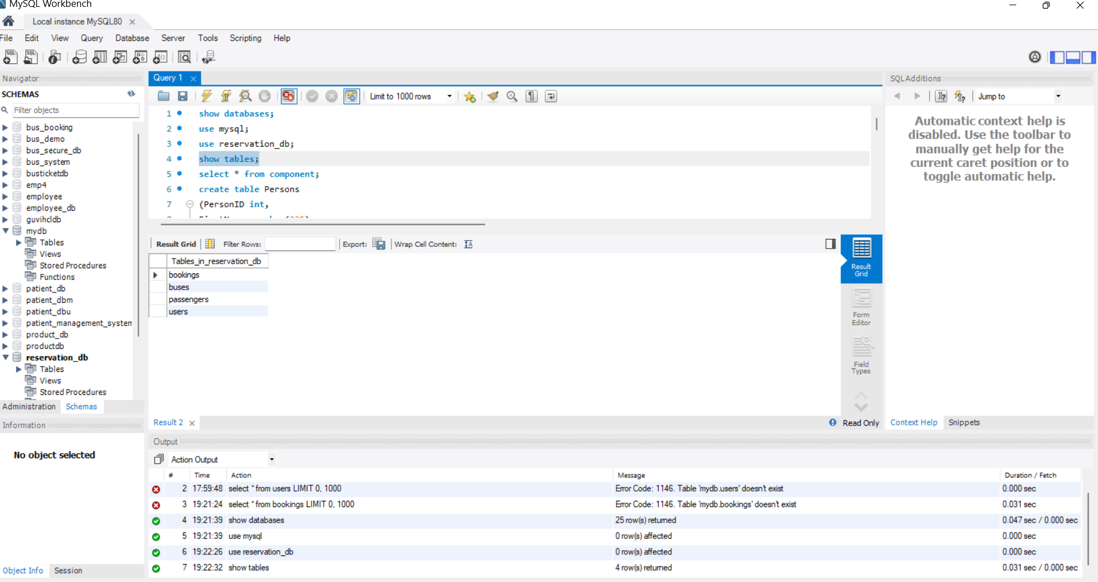

**Bookings**select * from Bookings;  
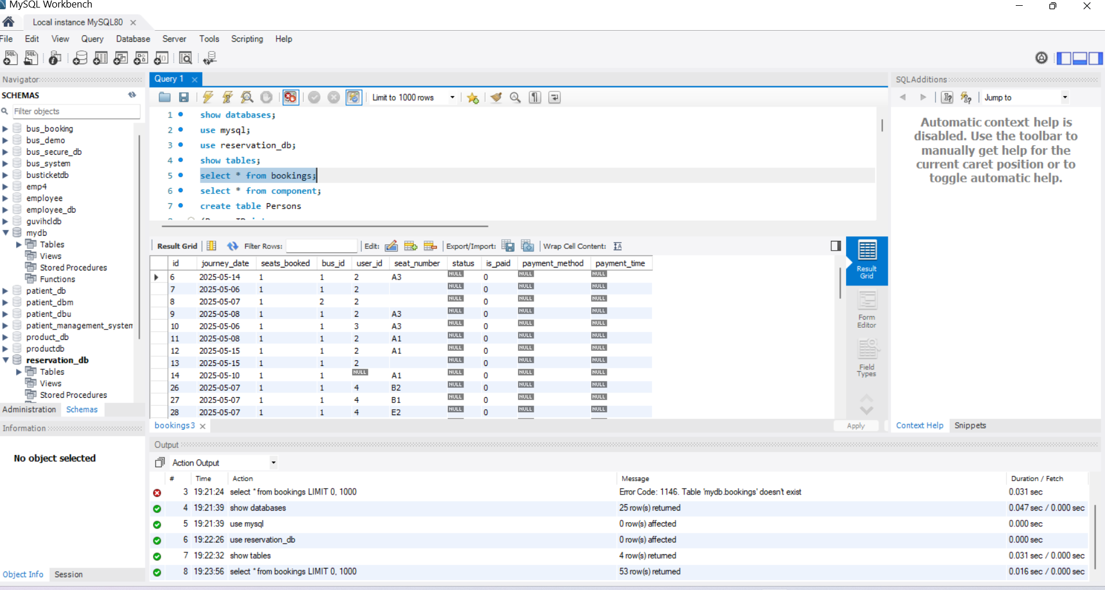

Select * from Buses;

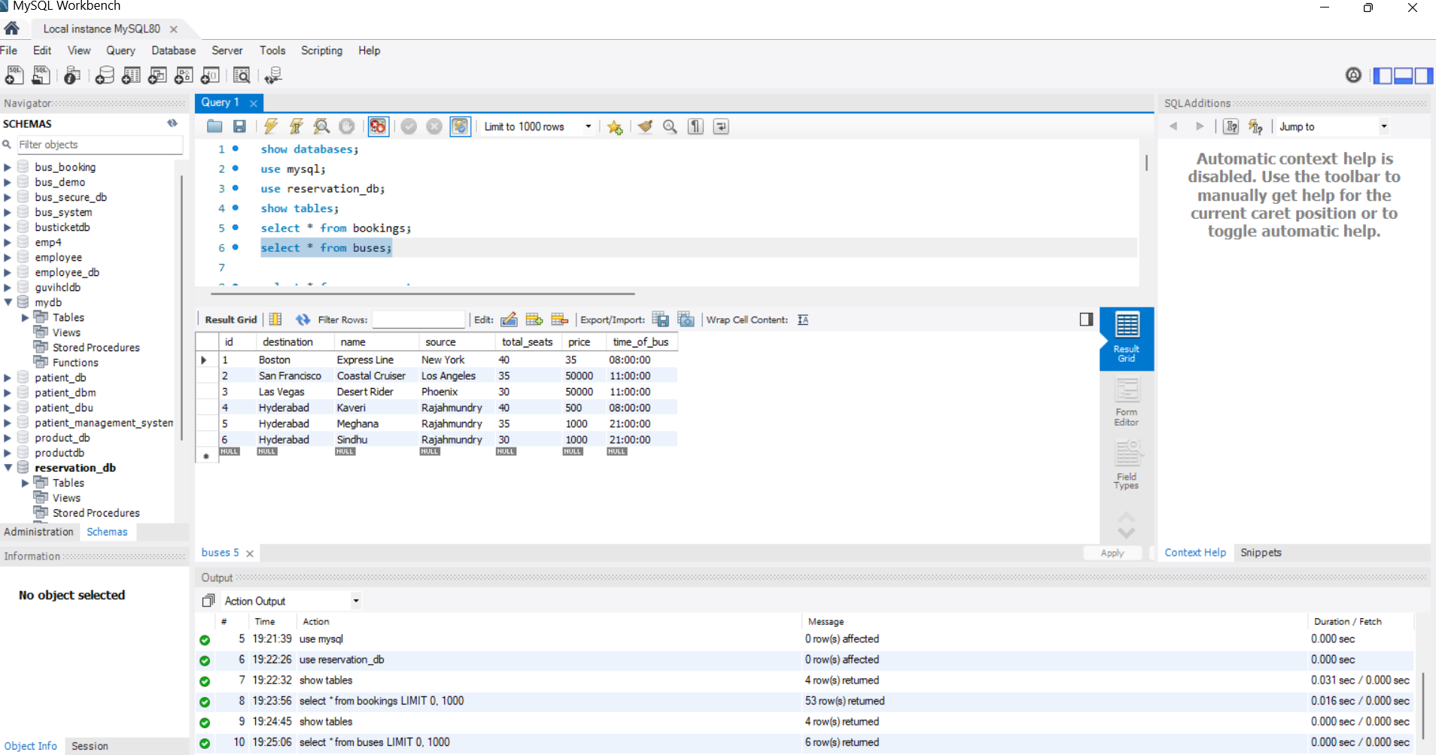

Select * from Passengers;

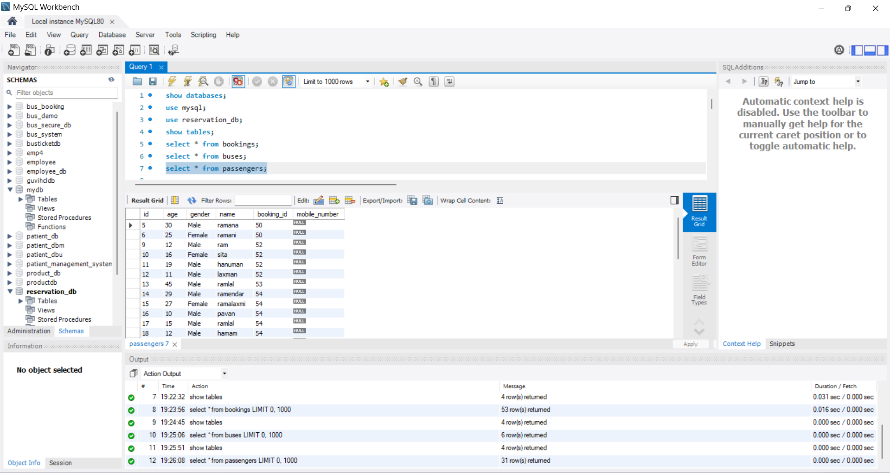

Select * from users;

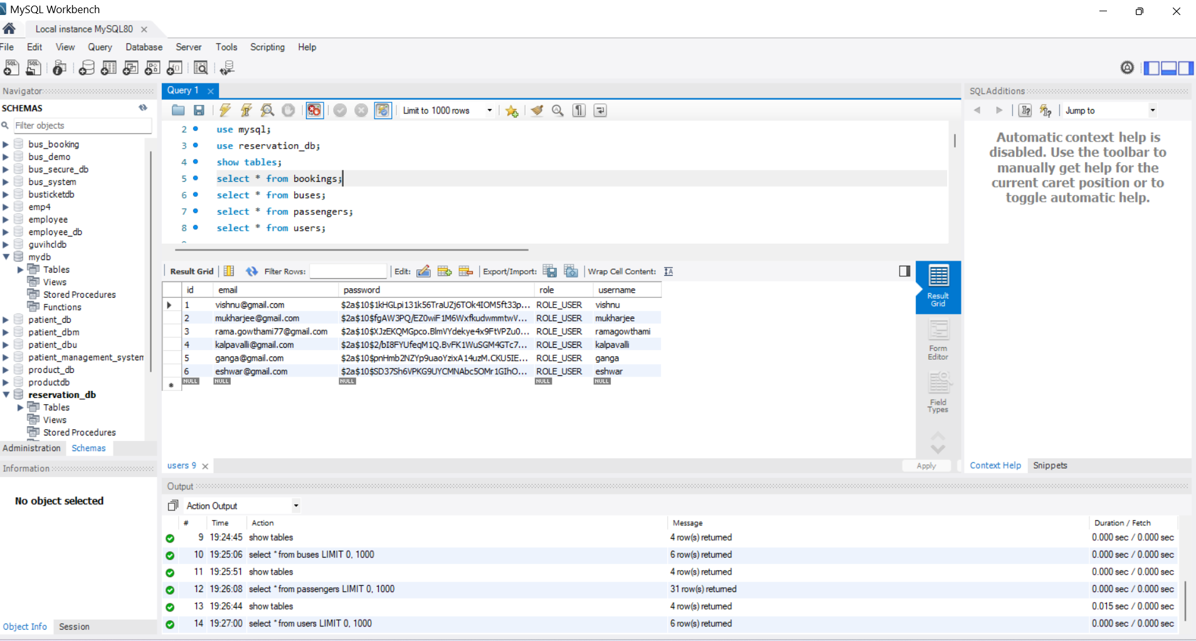

**After that I created corresponding Services and repositories.**

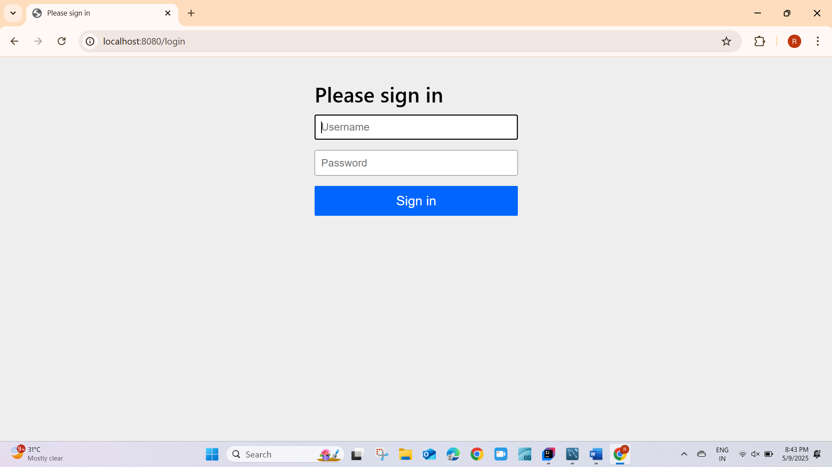

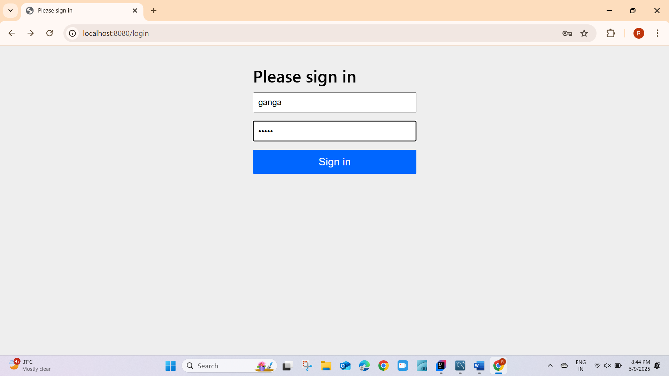

I create a user with name ganga and password ganga,if u want more users then fetch from database and password is same as username.ex:Vishnu,Eshwar also I created as users to login.

After login->this is **my homepage for BusBookingPortal.**

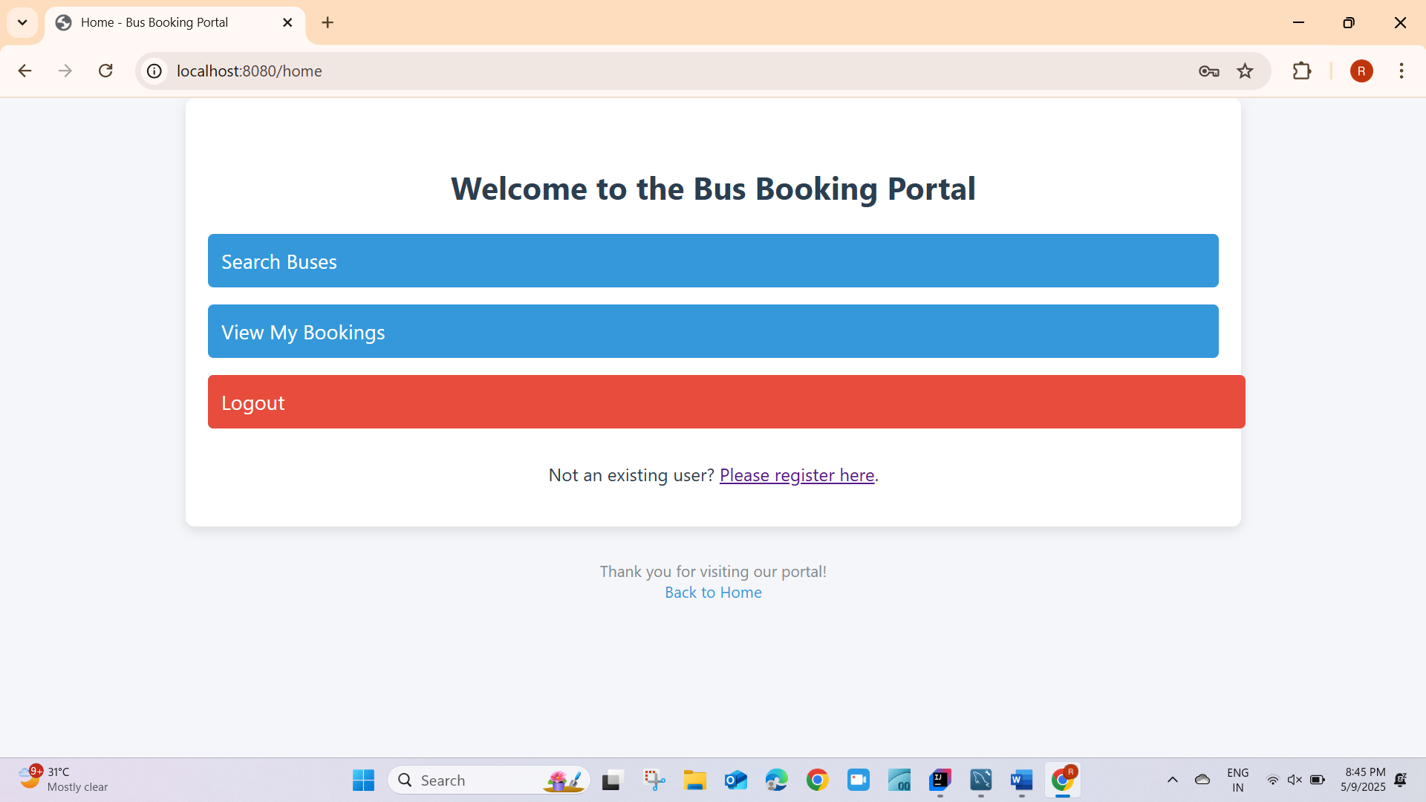

If u want to register user then user that link for registering user at bottom ,click on that then It will show like this below to add a new user for authorization.

**This is my Registeration form for a new User to get into the application either it is admin/user u can register here and use the application with this username and password.**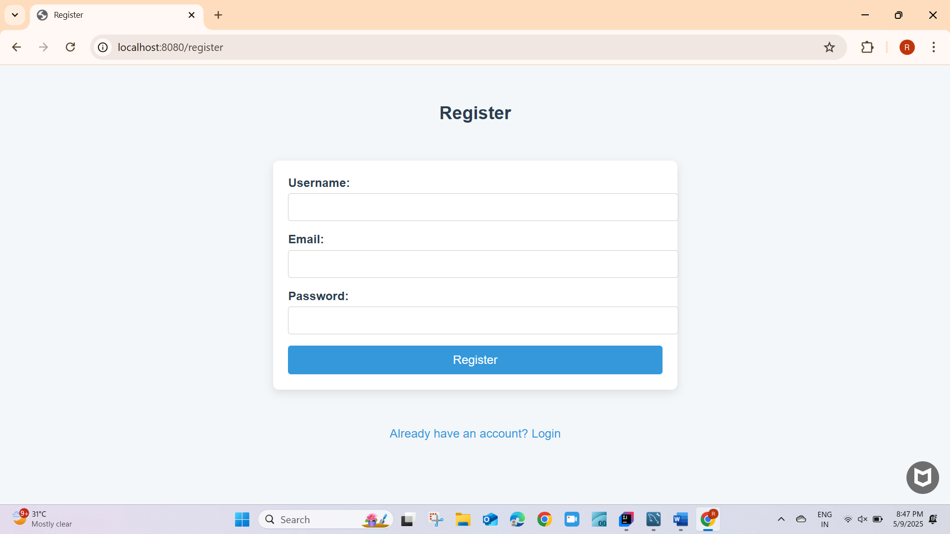

**Now I want to create a new user with username:star,email:star@gmail.com,Password:star.**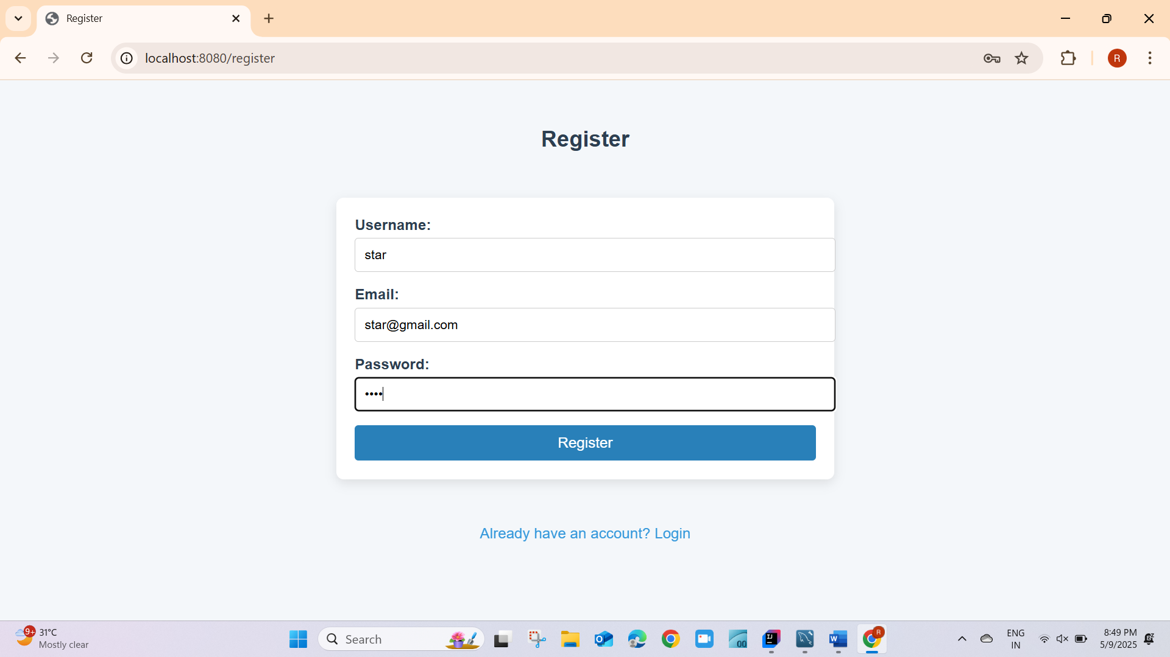

Now click on register->then it is redirected to login page with new user.

Or otherwise u can use localhost:8080/register also.,for registering new users.

->now I want to login with new username:star and password:star.

->Then it is going to <http://localhost:8080/home.and> shows homepage like this:  
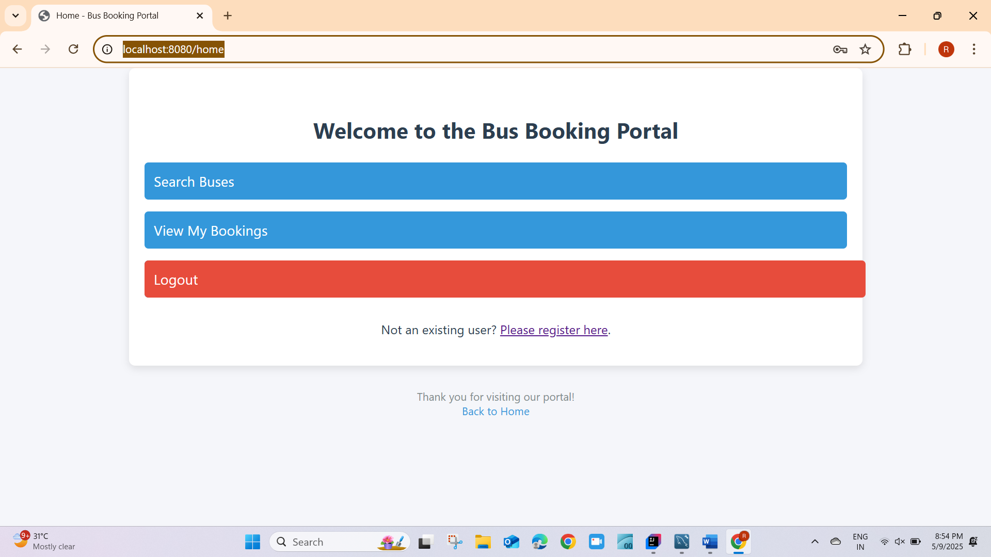  
now I want to search buses.  
->click on search Buses.  
->then it will go to <http://localhost:8080/bus/search>. And shows below form to search buses.

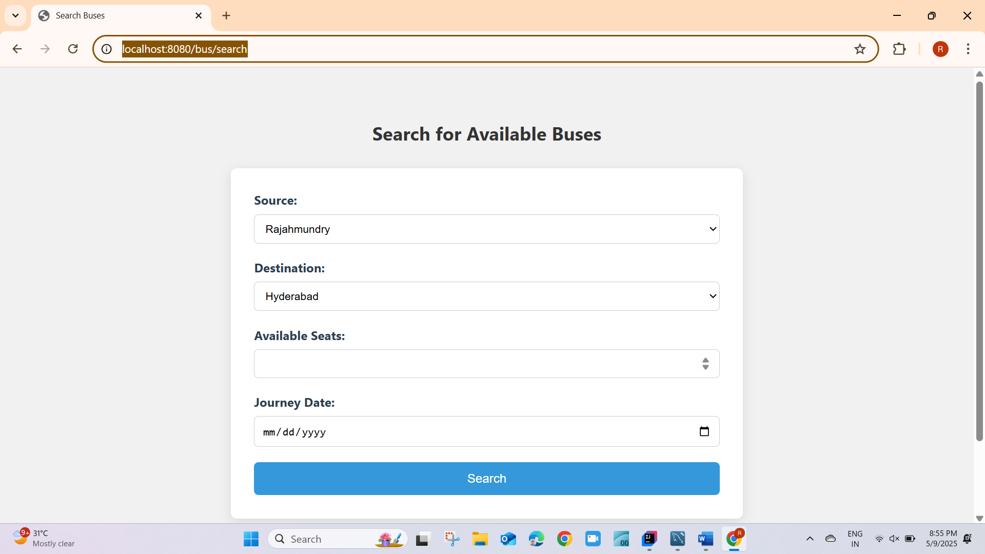

Now I want to search for Rajahmundry to Hyderabad.

**->select Rajahmundry from dropdown.**

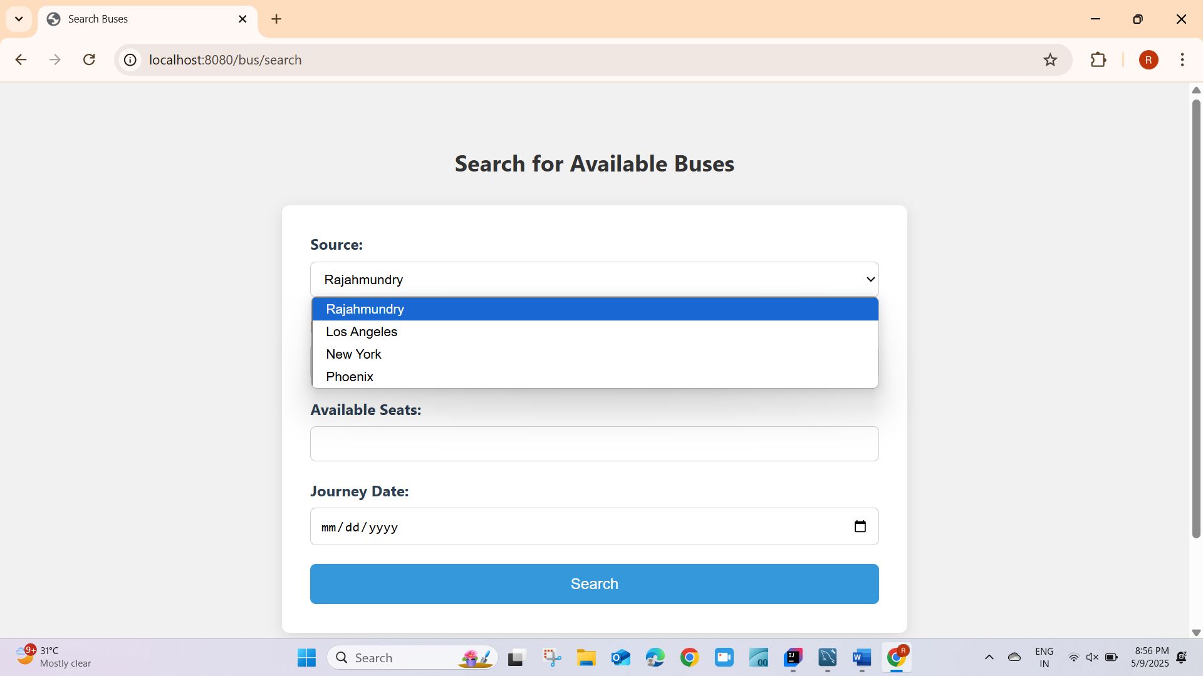

->select Hyderabad from the DropDown.

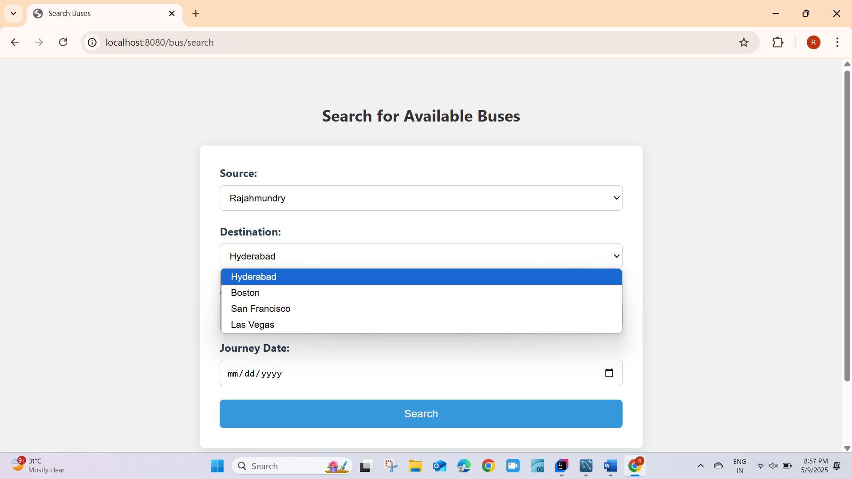

->select howmany seats u want any seats 1 to many.

->I am selected 2 seats.

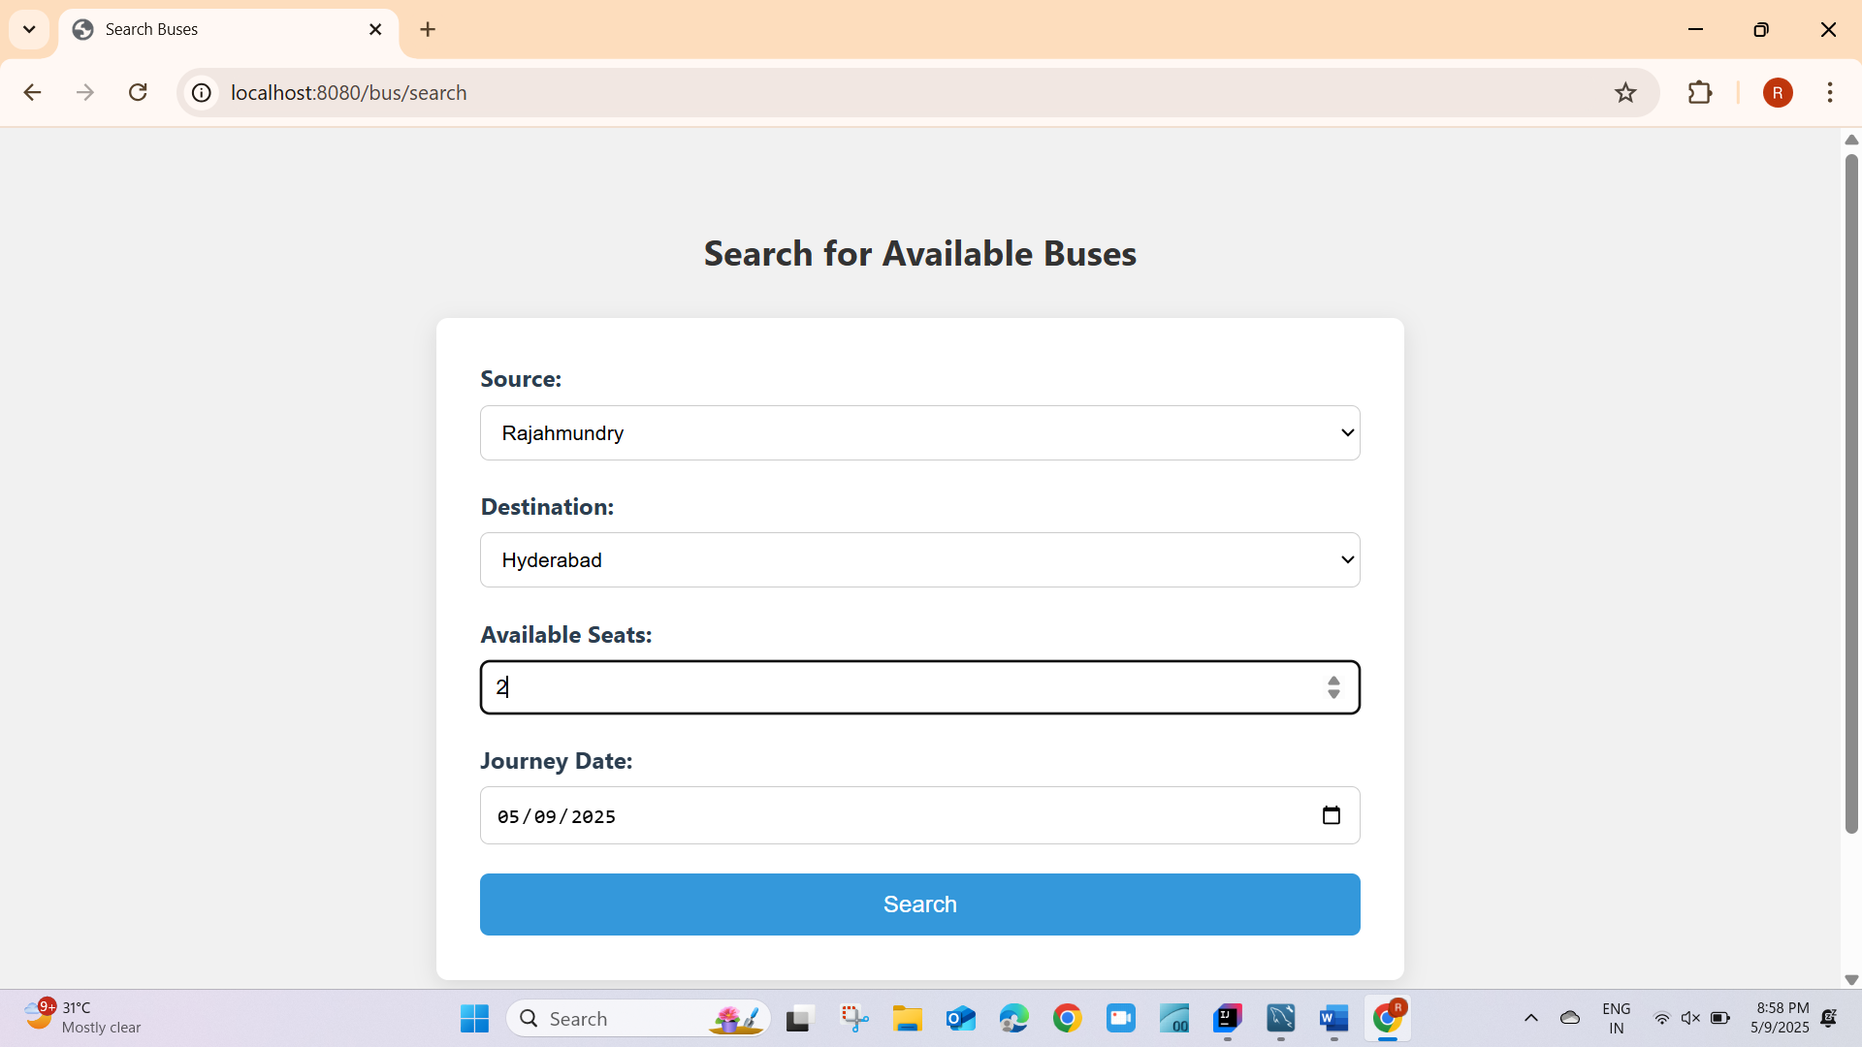

->Select journeydate from dropdown ,and click on Search.

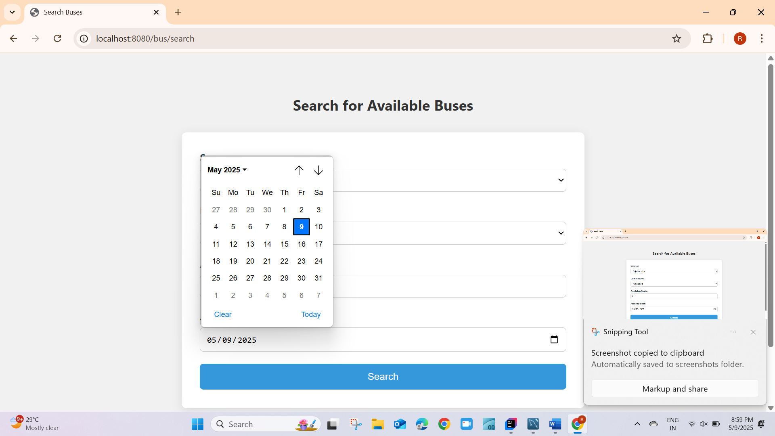

->now it is going redirected into <http://localhost:8080/bus/search/results?source=Rajahmundry&destination=Hyderabad&availableSeats=2&journeyDate=2025-05-09>

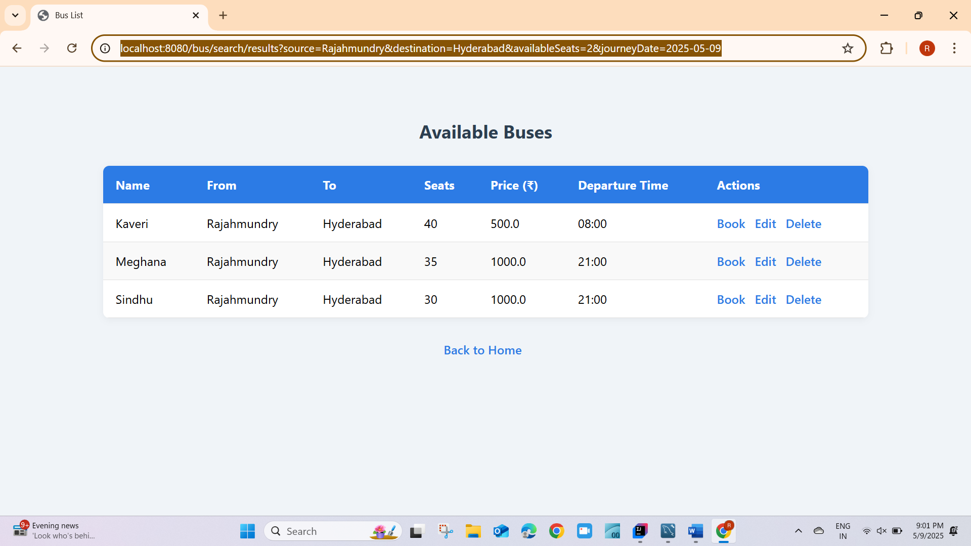  
->click on Book.  
->then It will enters into <http://localhost:8080/bus/book/4>

->Then select date,select on seat E1.

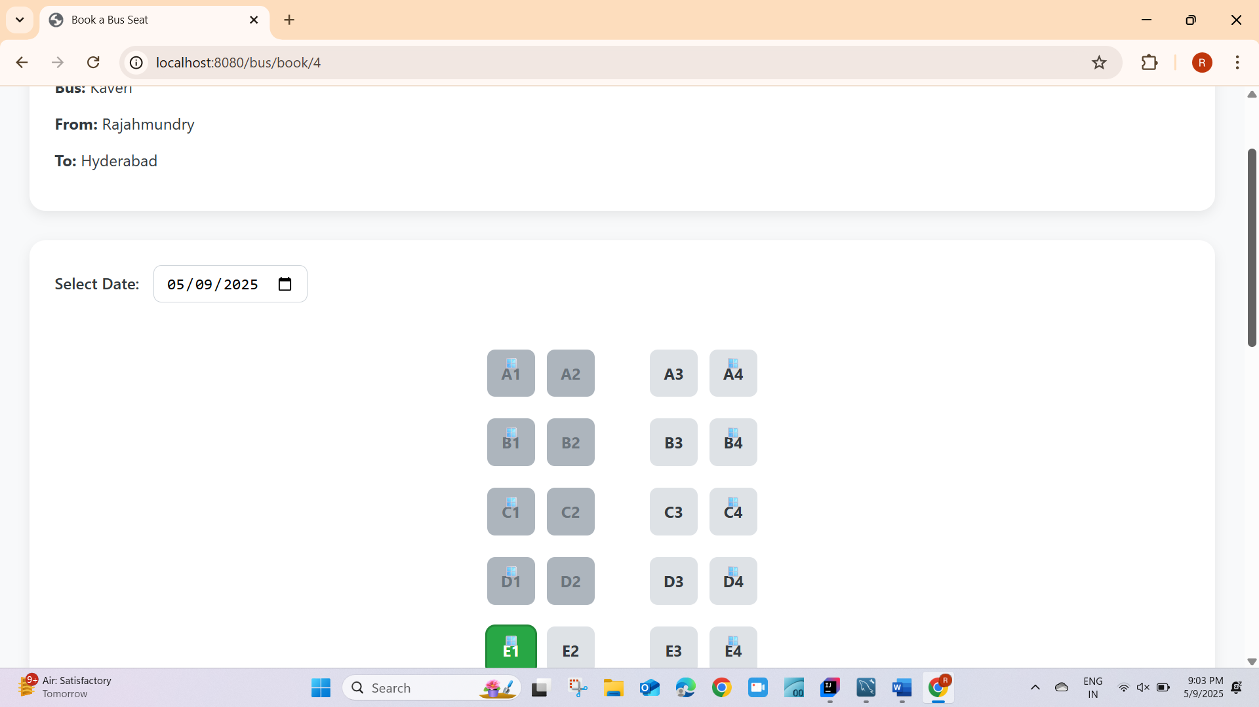

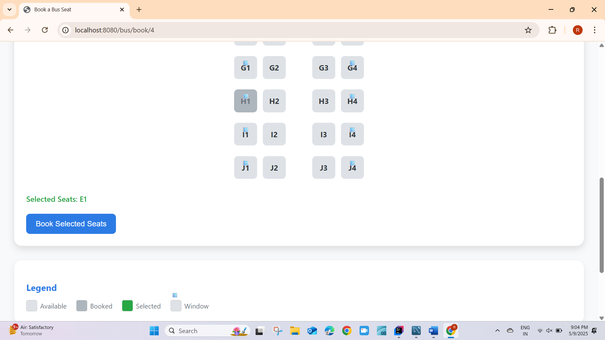

->Then clicked on Book Selected Seats.  
->Then It will redirected to

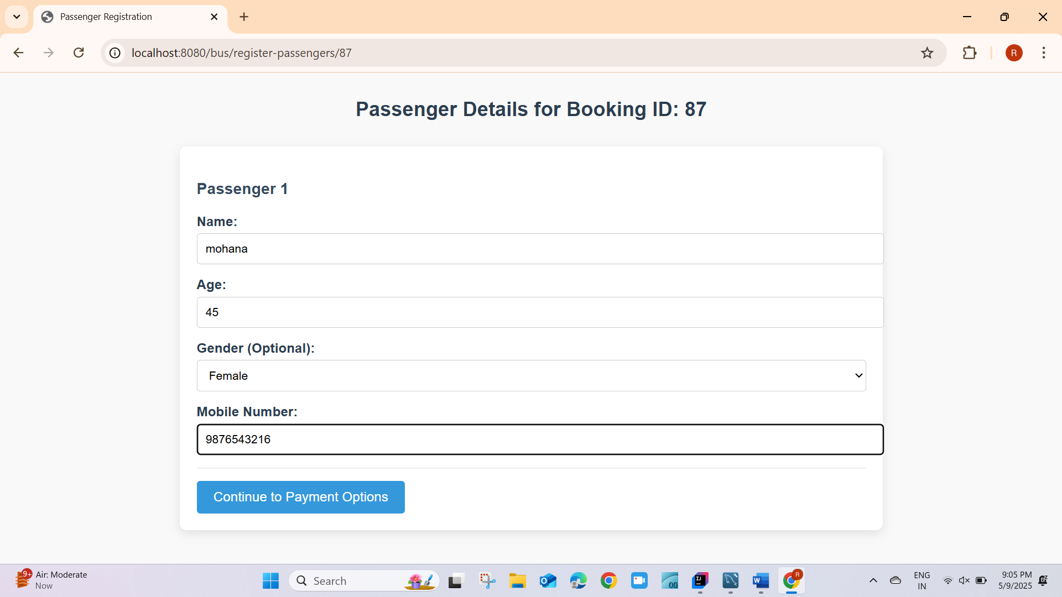

->give the Passenger Information

->click on continue Payment Options.

->Then It is redirected to <http://localhost:8080/booking/options?bookingId=87>

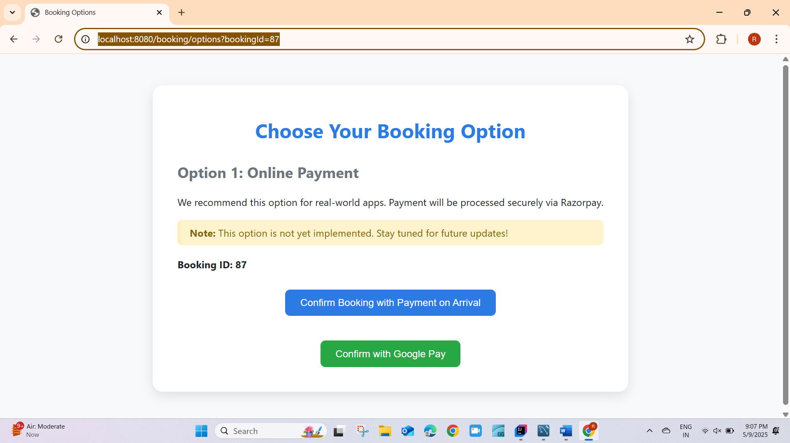

->now I clicked on confirm Booking with Payment on Arrival.

->then I go to <http://localhost:8080/booking/confirm-booking?bookingId=87>  
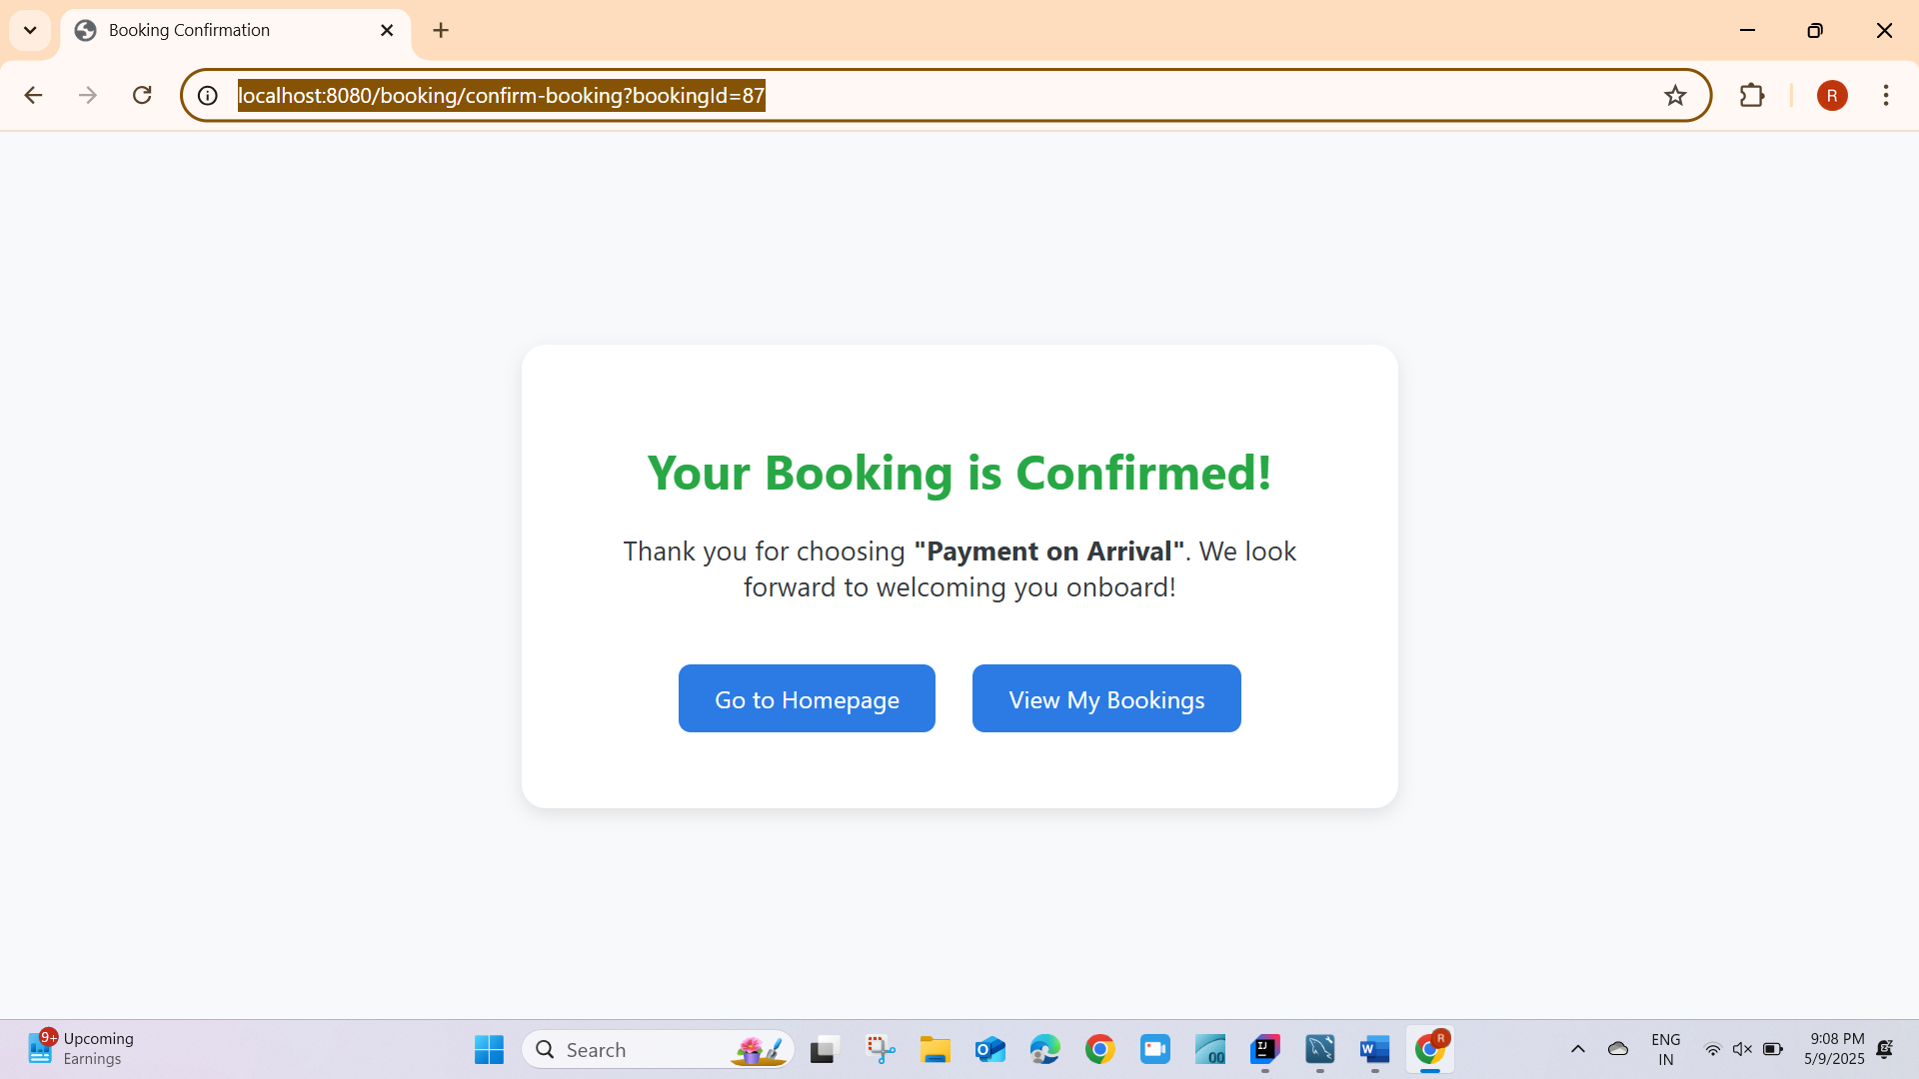

->Now, I want to see my Bookings.

->So, clicked on View My Bookings Button.

->Then It go to <http://localhost:8080/my-bookings>  
->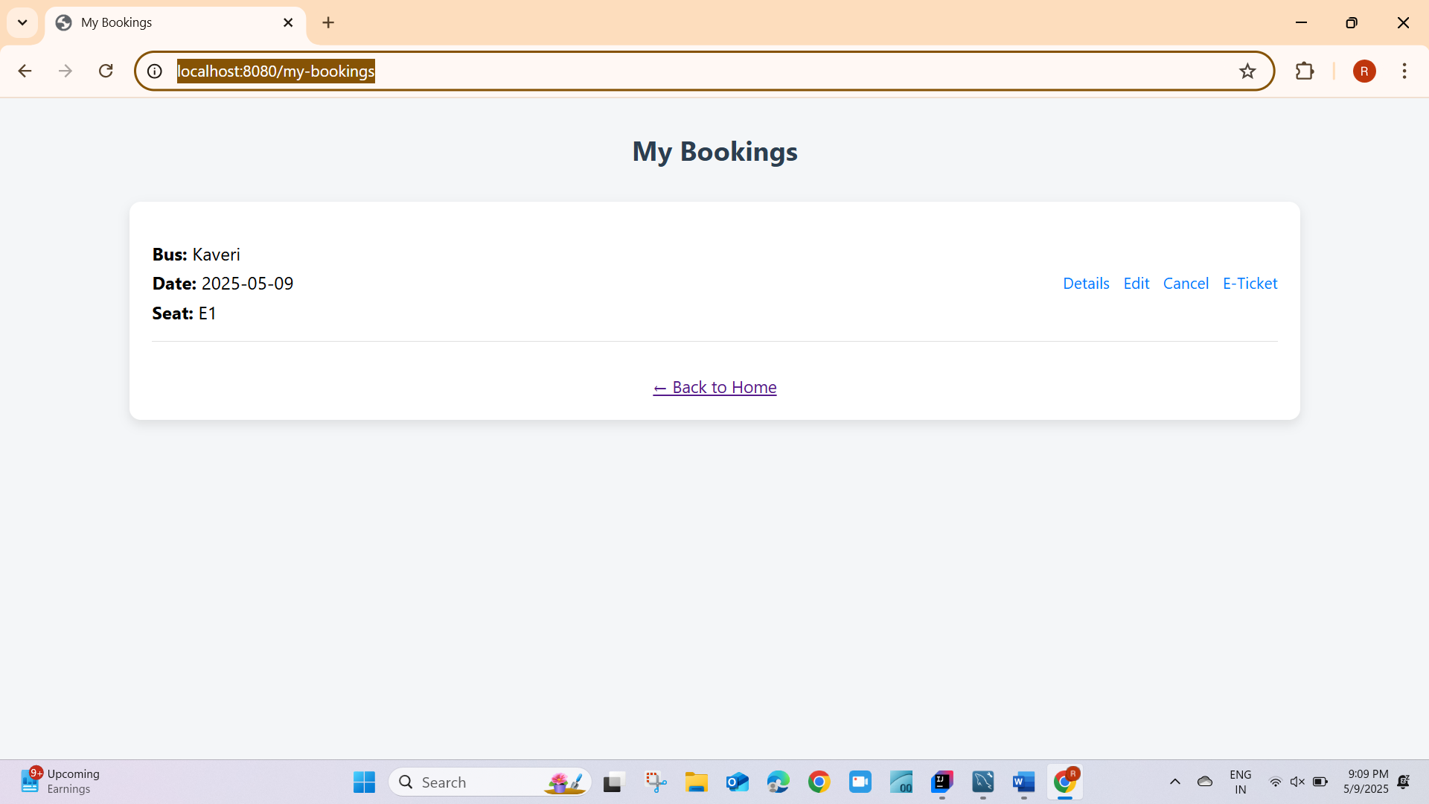

Now ,I want to see details about my ticket.

->for that I click on Details Button to render Details.

->then It will goto

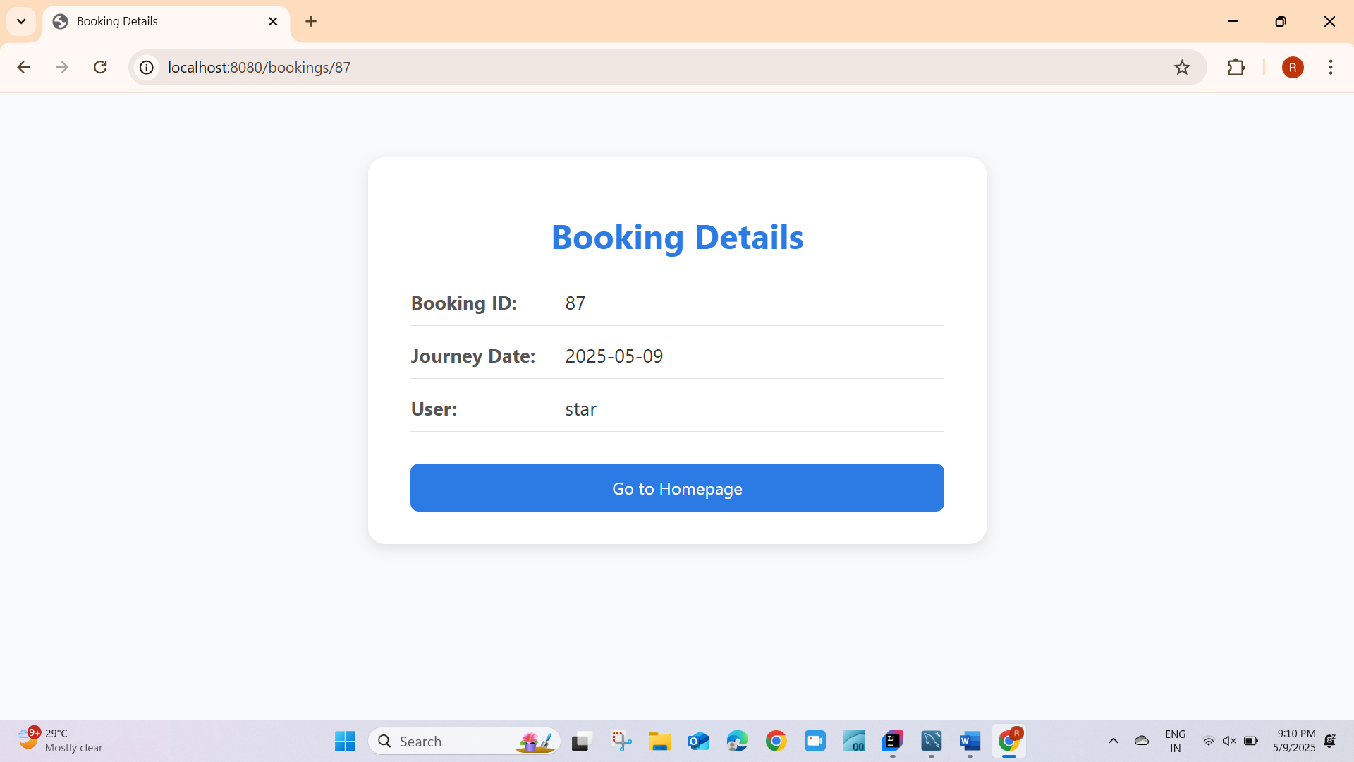

->now I want to Go HomePage,and again MyBookings.

->**so,In myBookings now I want ETicket,so click on ETicket**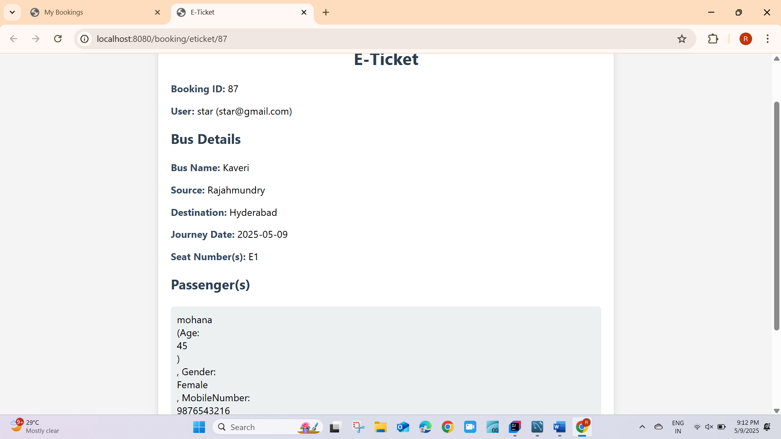

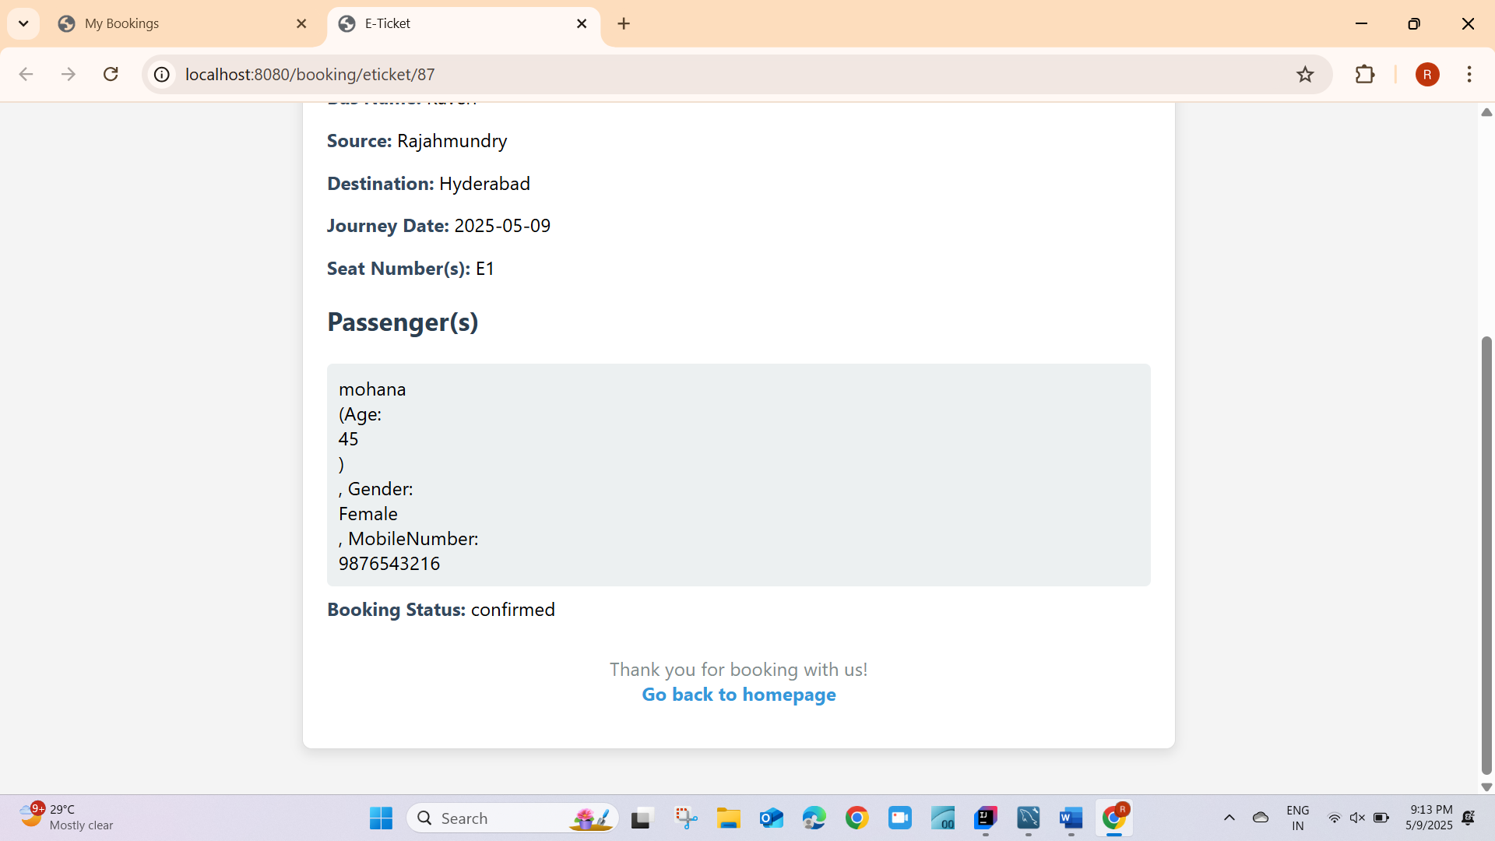

->I go back to Homepage

->Now I want to Edit/update the journey Date to 2025-05-10,so I want to click on Edit option in mybookings.

->Then It goes to <http://localhost:8080/bookings/edit/87>

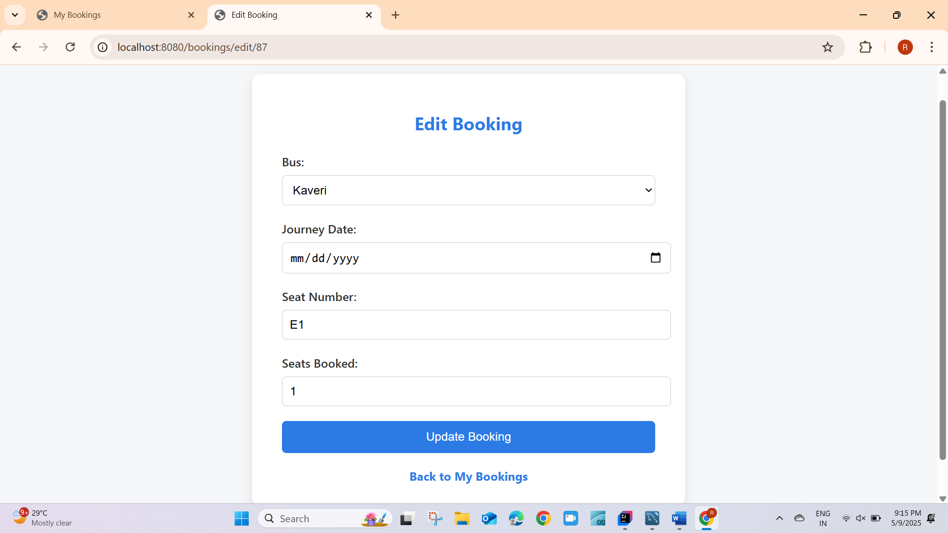

->so change date to 10/05/2025.

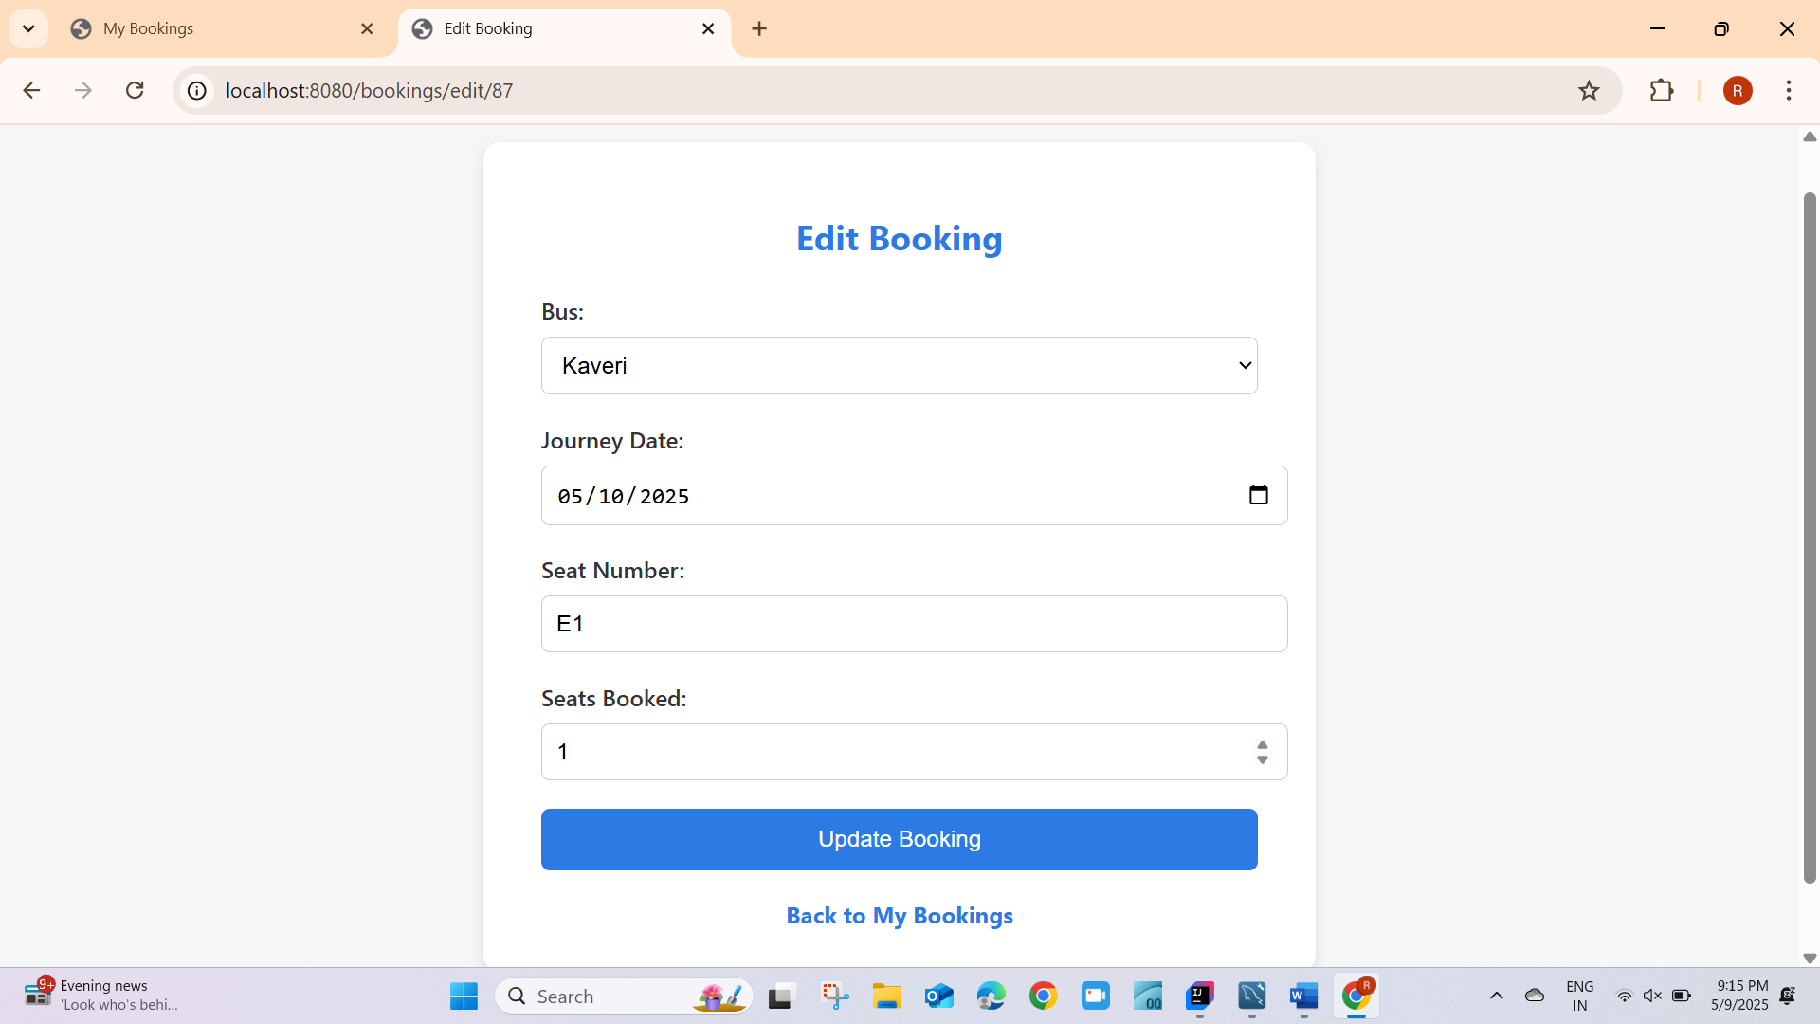

->click on UpdataBooking.

->

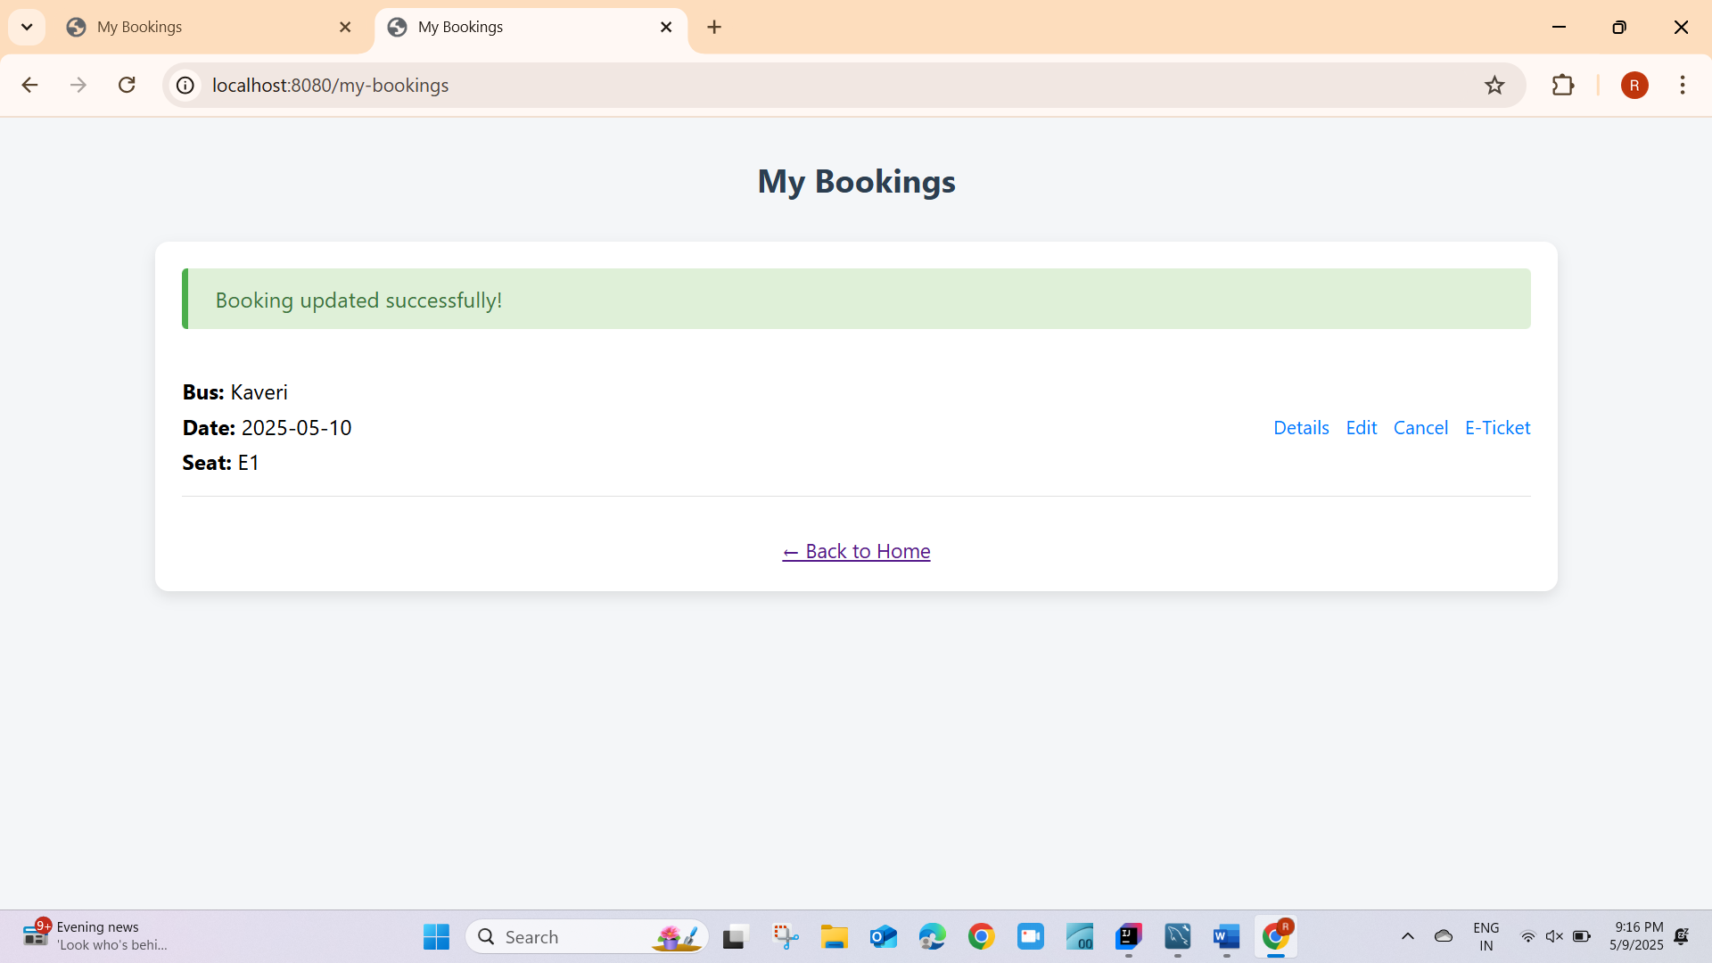

->Now,my ETicket changed as below,please observe.

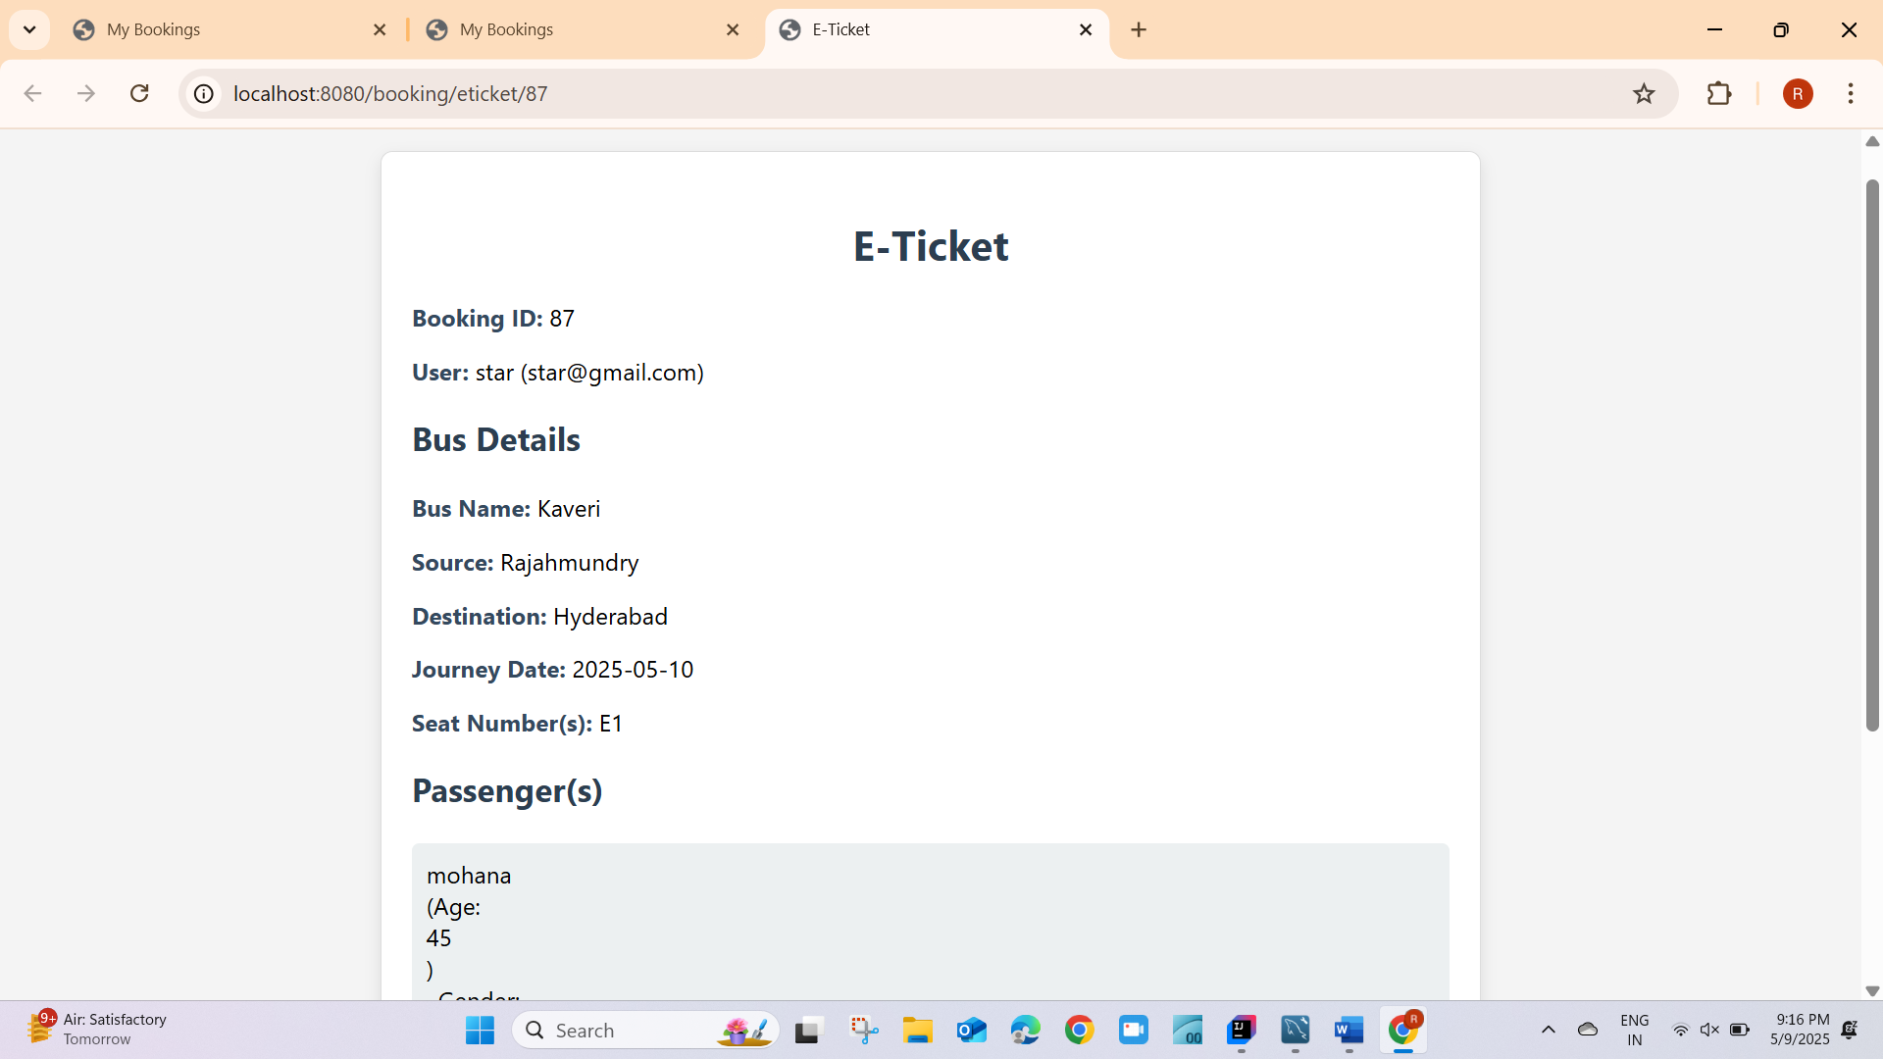

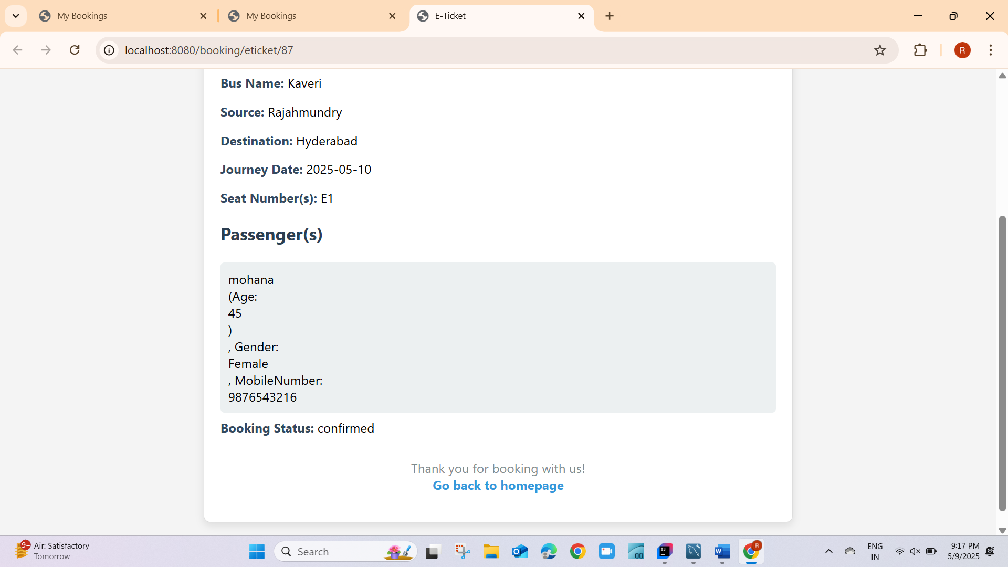

->If u want to cancel then click on cancel in MyBookings then it will cancel the ticket.as below popup will be open and asks then click on ok->then It will automatically deletes Ticket.

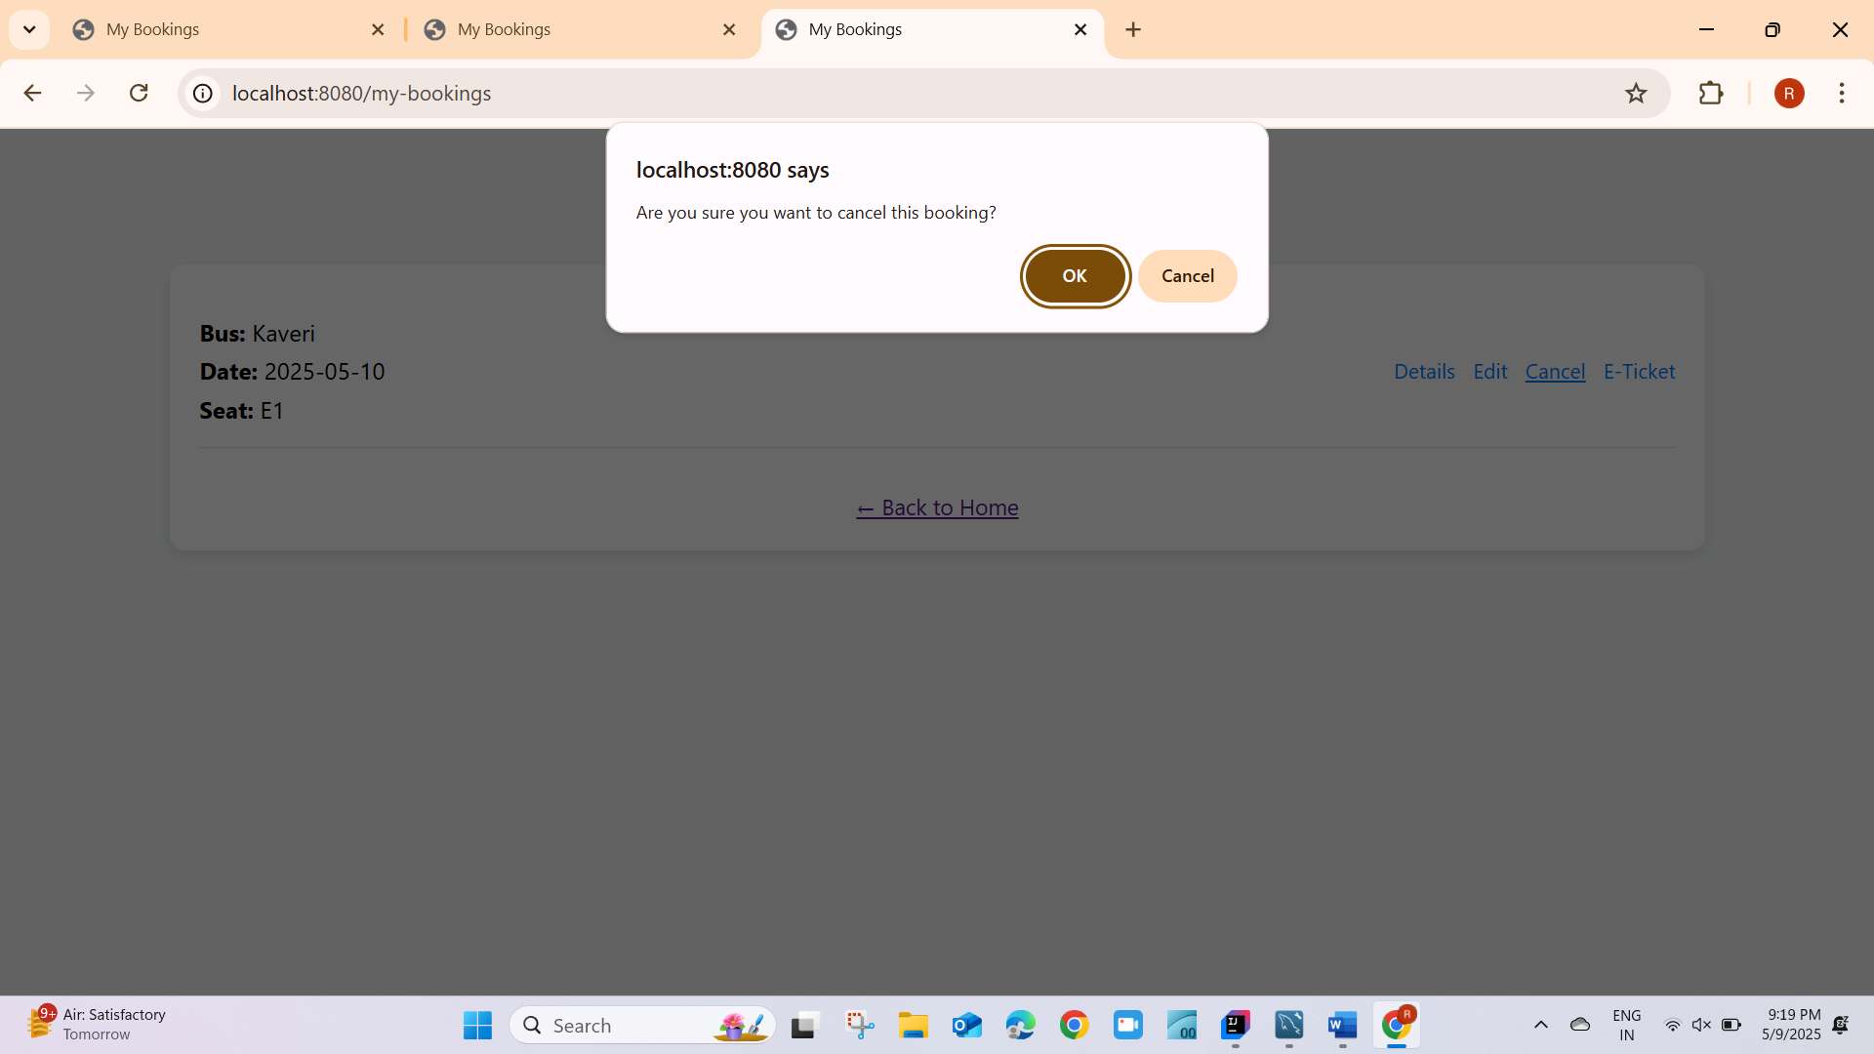

->If u wish to cancel->cancel

->Otherwise cancel the ticket then->cancel.

->similarly If I want to search buses in the route like LosAngels to Boston then It gives like as below.

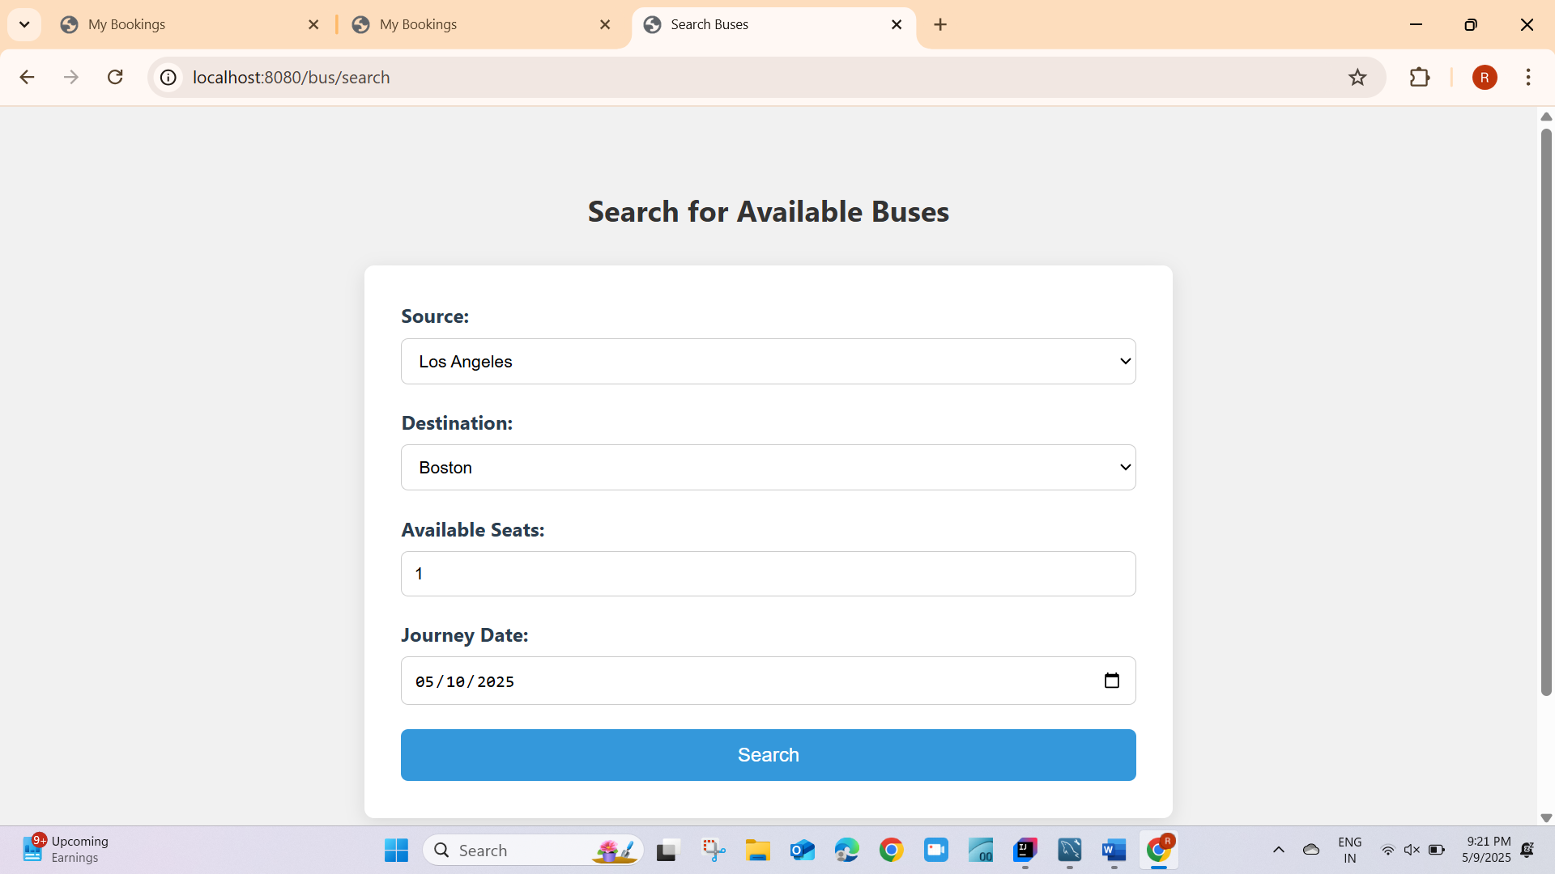

-

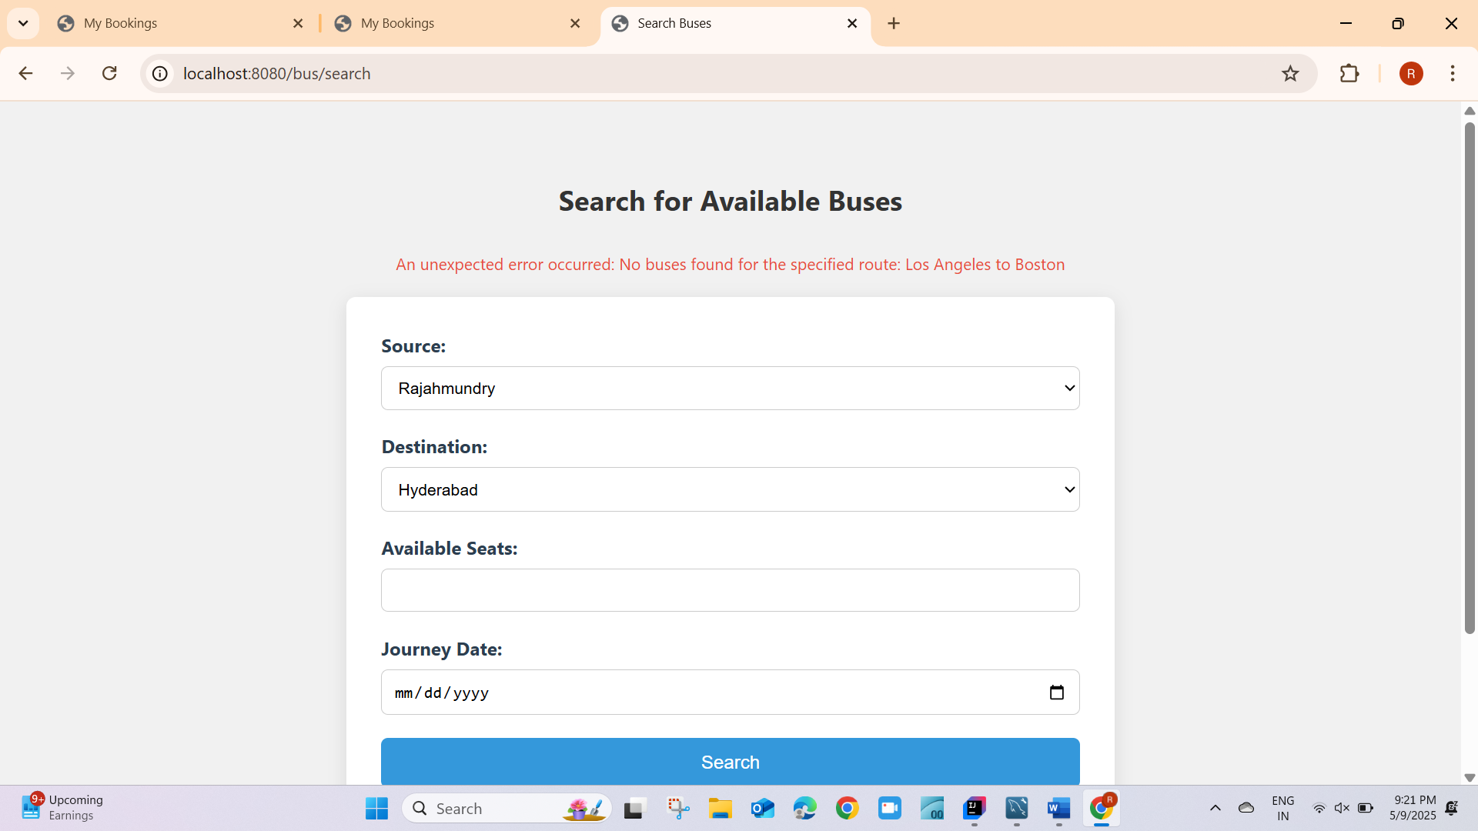

->This is the way my Bus Reservation System will work.,for Ticket Booking.

->Now If u want to change the Bus details like for admin user then

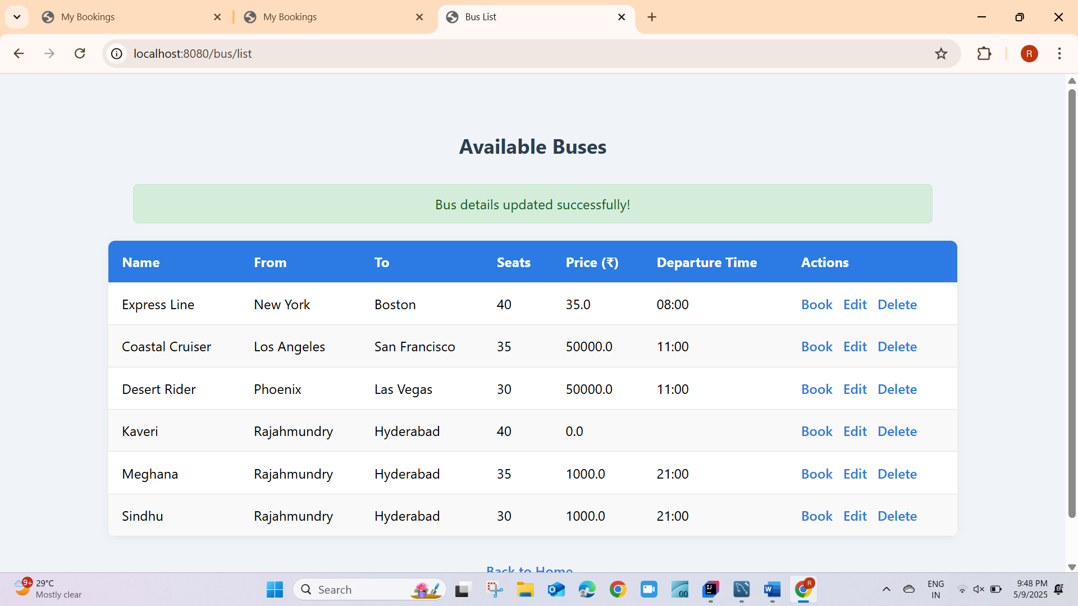

->Now I edit details for price and DepartureTime then   
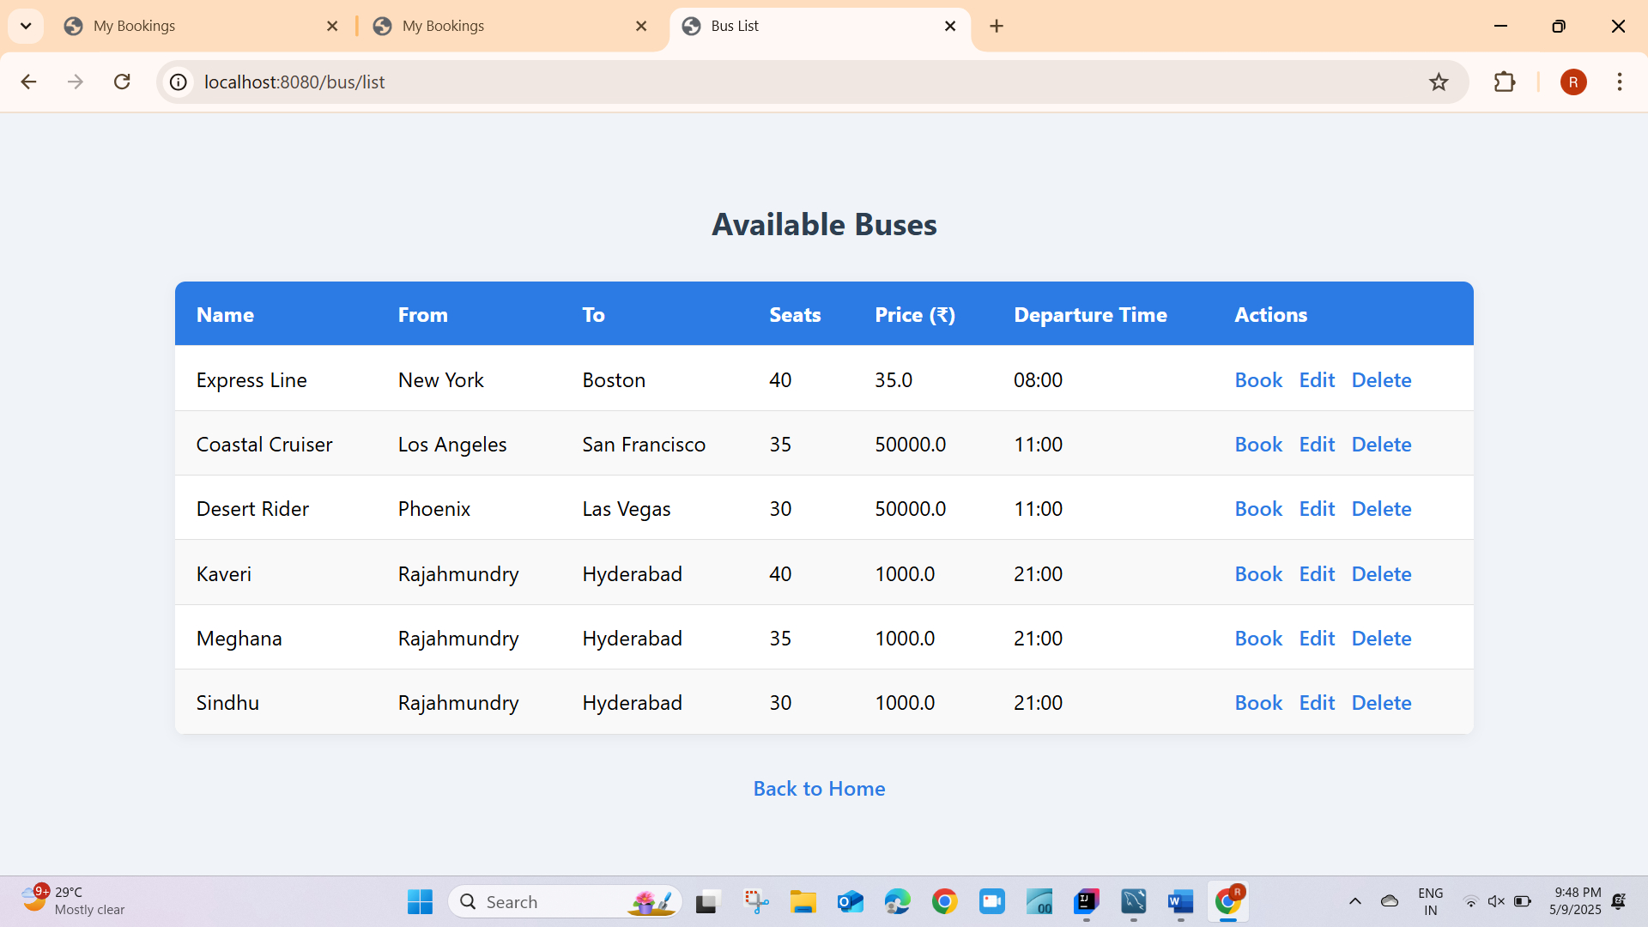

->If u want to Delete any Bus Information then click on Delete.

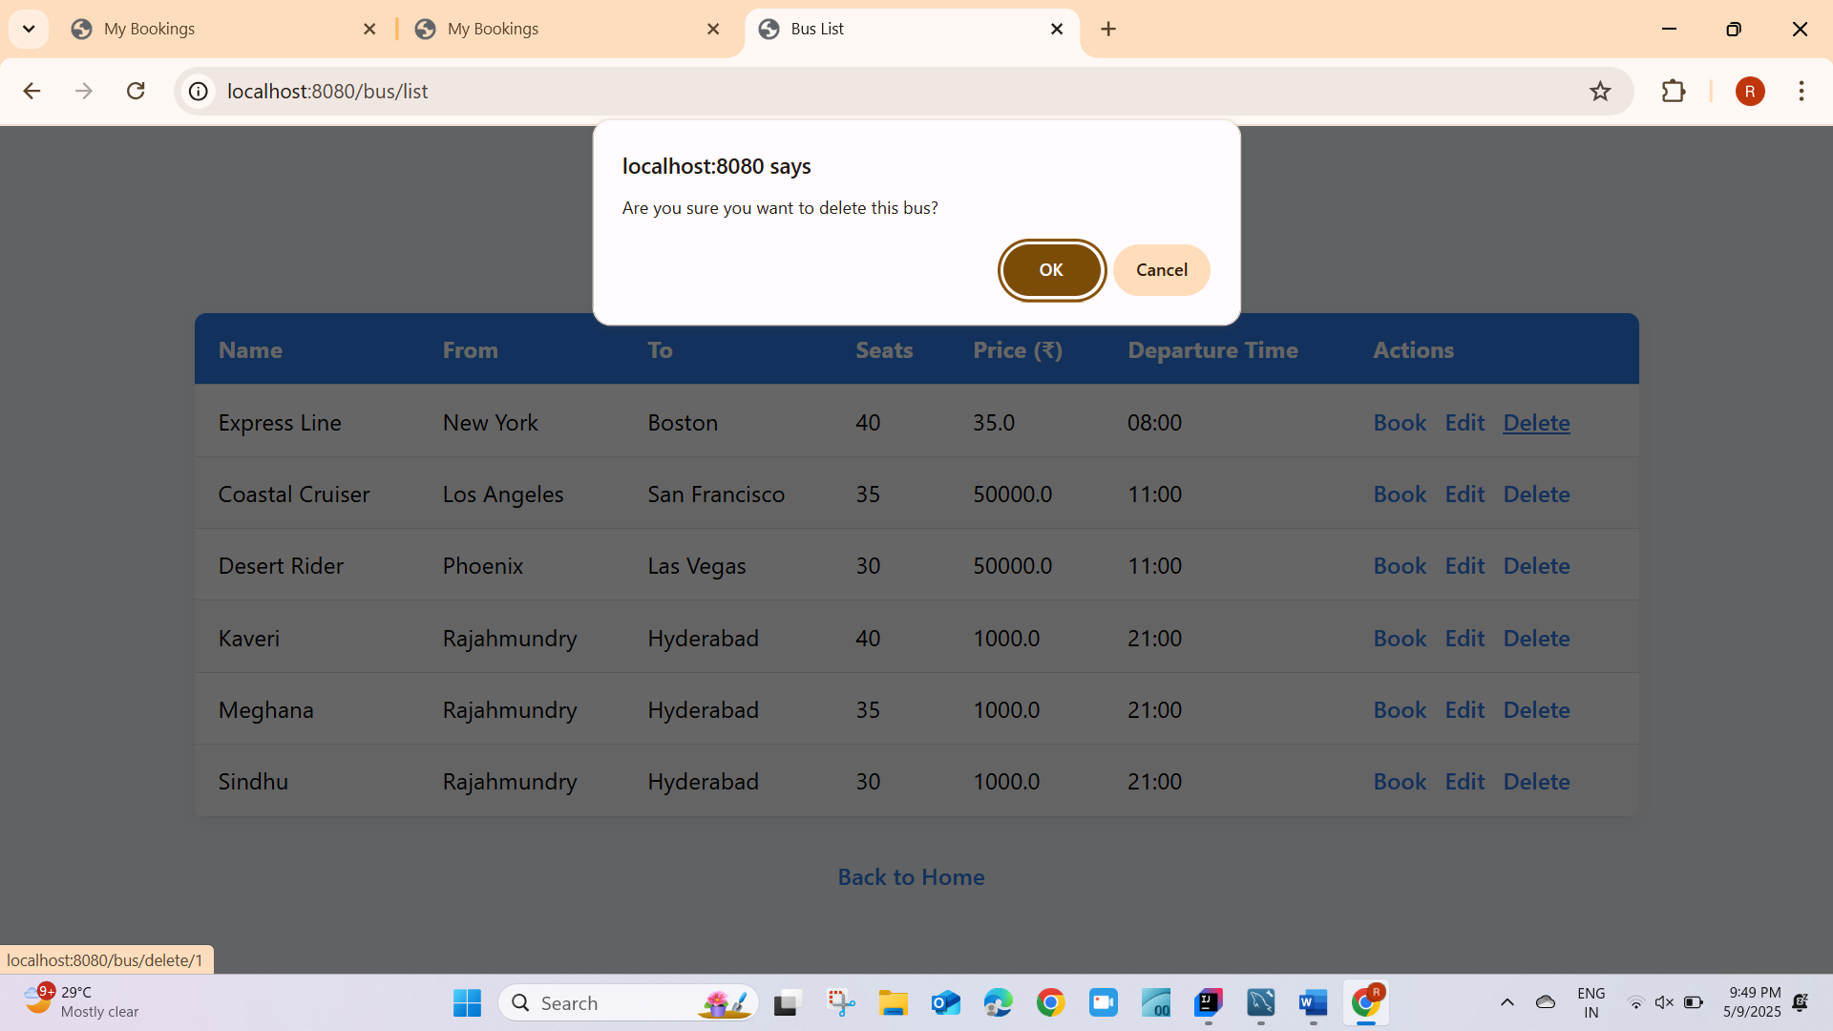

->click on Delete ,In this way we do crud operations on Bus too as a ADMIN User.

->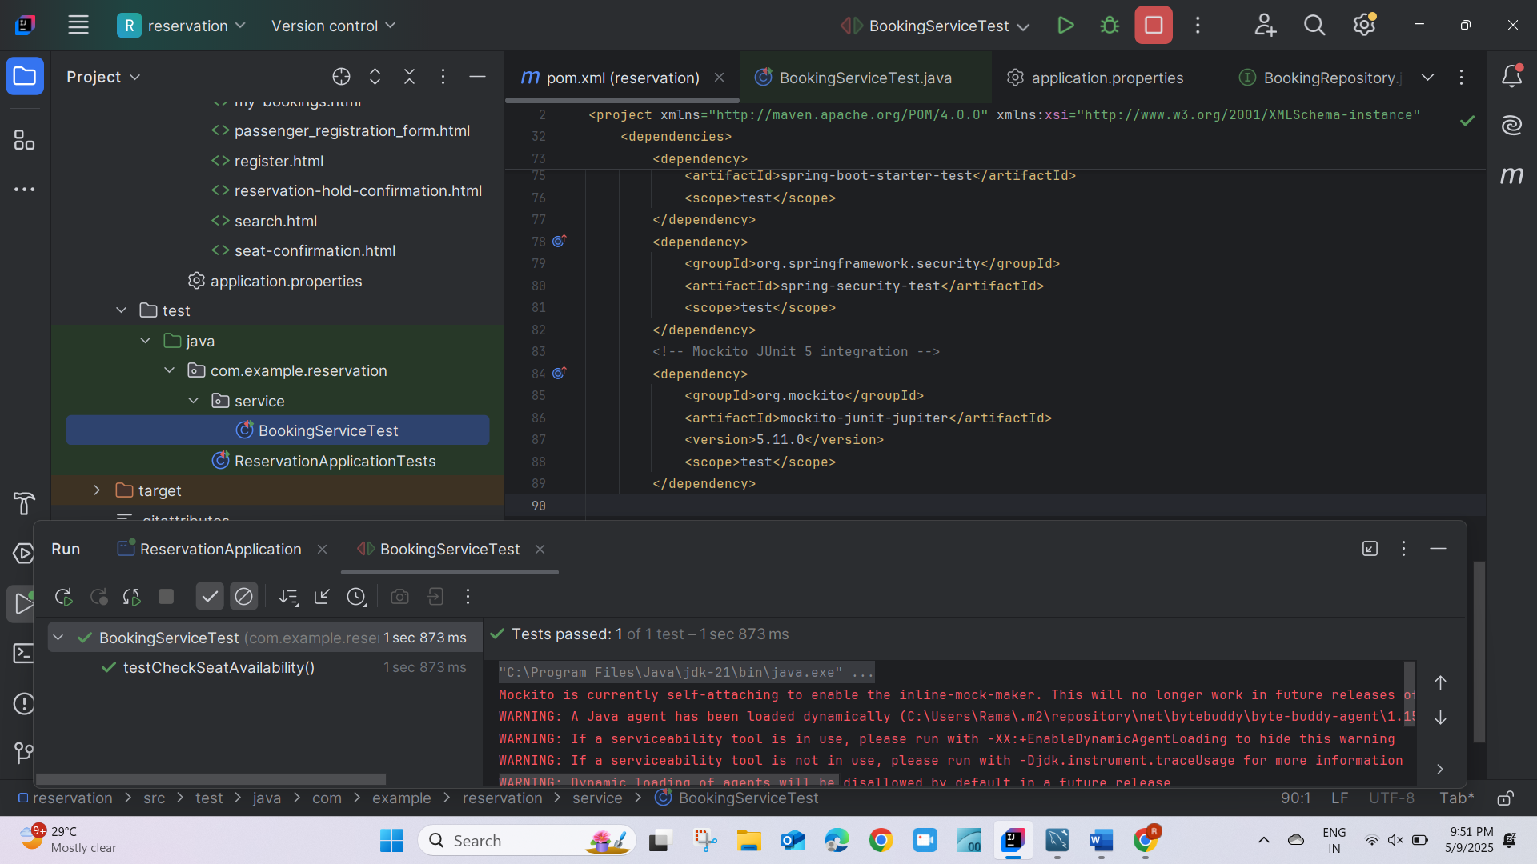

->I created Test Cases in Mockito,it passed the result.

->for swagger urls generated here.

